O & M MANUAL

Union Projects

Brucefield Industrial Estate Livingston
GES124

GES ELECTRICAL LTD
42 Victoria Road
Gourock
PA19 1DB
Tel/Fax 01475 713462

I N D E X

D E S C R I P T I O N S E C T I O N No.

Introduction 1

Warning Notes 2

Operating Instruction 3

Servicing 4

Light Fittings/Spares and Parts List 5

Distribution Panel/Parts List 6

Fire Alarm Panel/Parts List 7

Miscellaneous 8

Inspection & Test Certificates 9

Contract Drawings 10

S E C T I O N O N E.

Introduction.

GES ELECTRICAL LTD carried out the electrical installation at Brucefield Industrial Estate Livingston.

This operation manual provides detailed information for maintenance engineers in the future for guidelines of replacement part and guidelines to maintenance.

No arbitrarily ruling can be given regarding the length of time to lapse between periodic inspection as obviously this depends on the client and the infrastructure of maintenance, security, site environmental and climate conditions. We as a company would recommend that the client implements a maintenance schedule to be carried out on a regular basis, experienced personnel in the electrical field should implement this and a form of record left in this file.

It should be noted that before carrying out any maintenance checks or adjustments of any electrical components, the equipment should be isolated and locked off from the source of electrical power supply.

For and on behalf of

GES ELECTRICAL LTD

S E C T I O N T W O.

WARNING NOTES.

- Do not fit fuses and MCB of larger capacity than supplied within the electrical distribution panel or any fusible item.

- Make sure a full compliment of spare parts e.g. lamps for light fittings are always available, particularly parts most often replaced, and a record left.

- Maintenance should be carried out by experienced, qualified electrical personnel only and safe isolation procedures implemented at all times when works are being carried out.

- The cause of any circuit breaker to trip must be investigated and eliminated at all times before the power be reapplied to any circuit.

S E C T I O N T H R E E.

Operating Instructions.

Electrical Distribution

- The main electrical distribution is situated in the basement level of the building. Scottish power cable head is situated to the left hand side of the main electrical panel’ with there 3-phase 4.5v main switch situated on the wall next to the mains panel, this switch if switched to the “OFF” position would isolate the main incoming power supply to the electrical installation within the building.

- Localised isolation of circuits can be done from the main electrical panel. All circuit breakers have a legend explaining a brief detail of its operation located to the centre of the panel. Each circuit breaker clearly states whether it is in the “ON” position or the “OFF” position for maintenance purposes circuit breakers should be locked off and labelled clearly that personnel are working on circuit, we recommend that a clear procedure be put in place by client to ensure that this is adhered to at all times and by Experienced electrical personnel only.

Lighting

- All light fittings are operated via localised switches in each room of building.

Emergency Lighting

- Next to each light switch an emergency light test switch is located this is for maintenance purposes only – please refer to emergency lighting section for a more detailed account of operation.

Power Socket Outlets

- All socket outlets are 240v 13amp 3-pin outlets, please note that all appliances should have correct fuse value installed and be certified portable appliance tested. All socket outlets have RCD protection.

Fire Alarm

- Fire Alarm System is a fully automated system, consisting of fire alarm panel situated at front entrance, combined sounder and smoke detection situated at the roof level and emergency break glasses situated at each exit/entrance to building.

Outside Lighting

1. Outside lighting can be operated via switch in the main reception area located on side wall of I.T. cupboard.

S E C T I O N F O U R.

Servicing.

SERVICING OF THE CONTROL GEAR, SWITCH GEAR, LIGHTING, FIRE ALARM SYSTEM – Should be carried out by Experience Personnel only.

- Inspect for loose connections, and tighten nuts, bolts, electrical connections, care should be taken when removing any covers, always make sure all exposed electrical connections have been isolated before carrying out any servicing.

- Examine all switches, control gear, distribution, and lighting socket outlets for signs of overheating or wear and tear, replace if necessary.

- Check all fuses have the correct rating and are in healthy condition.

- Log and report all servicing and list all new parts within this folder.

S E C T I O N F I V E.

Light Fittings/Lamps

ASCOT TWIN S/S 6FT BATTEN REF: AB62LX
ASCOT SINGLE S/S 6FT BATTEN REF: AB61LX
ASCOT TWIN S/S 5FT BATTEN REF: AB52LX
ASCOT SINGLE S/S 5FT BATTEN REF: AB51LX
ASCOT SINGLE PRISMATIC DIFFUSER REF: AC61
ASCOT TWIN PRISMATIC DIFFUSER REF: AC62
ASCOT REFLECTOR REF: ASR6
ASCOT LOWBAY C/W LAMP REF: ALB250B

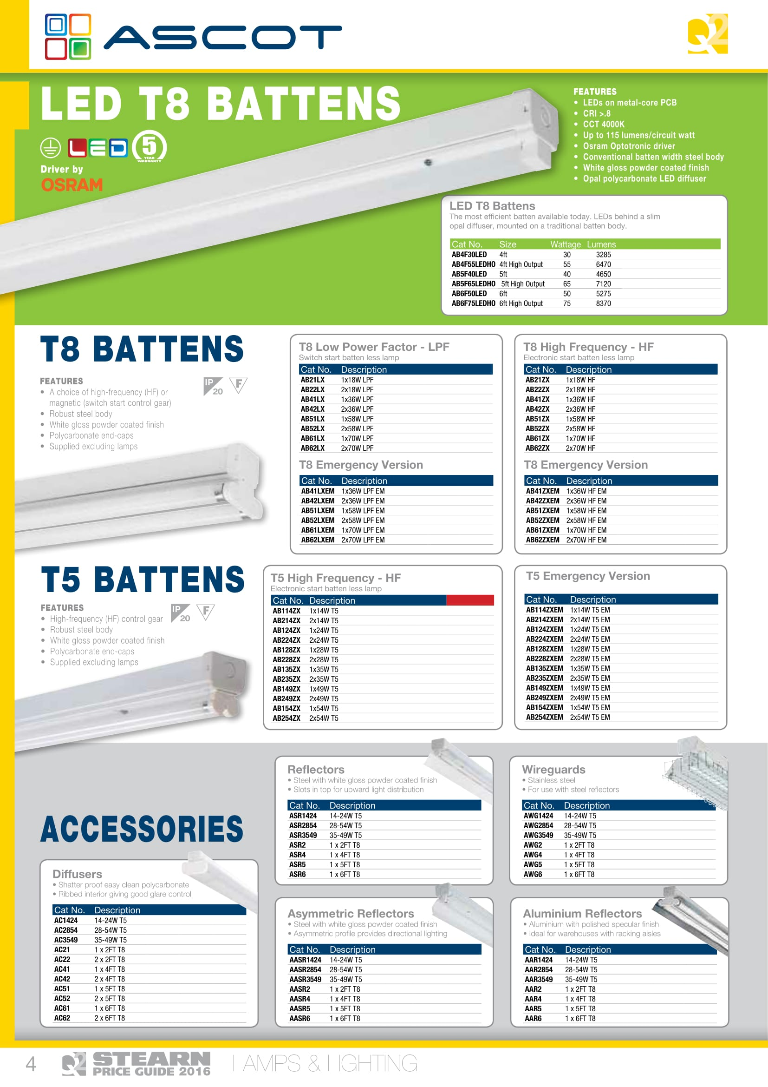
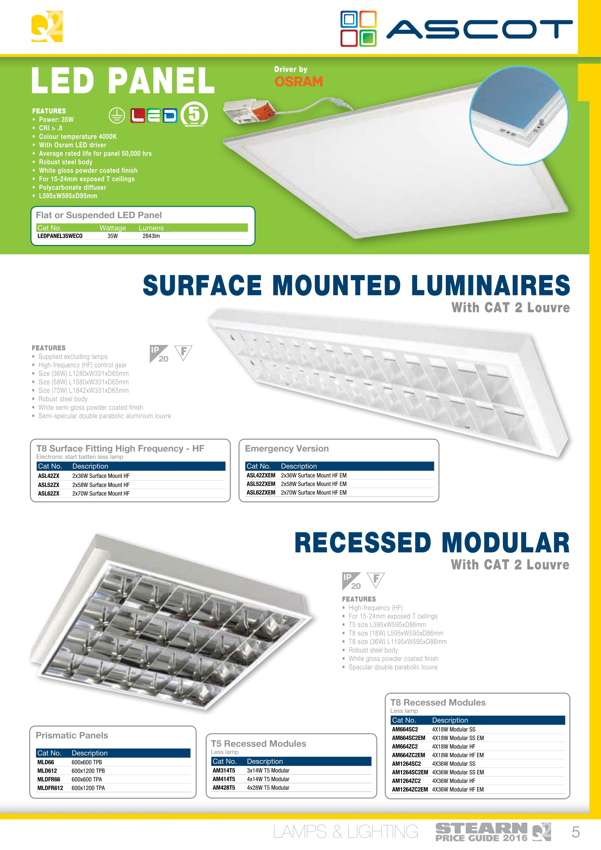
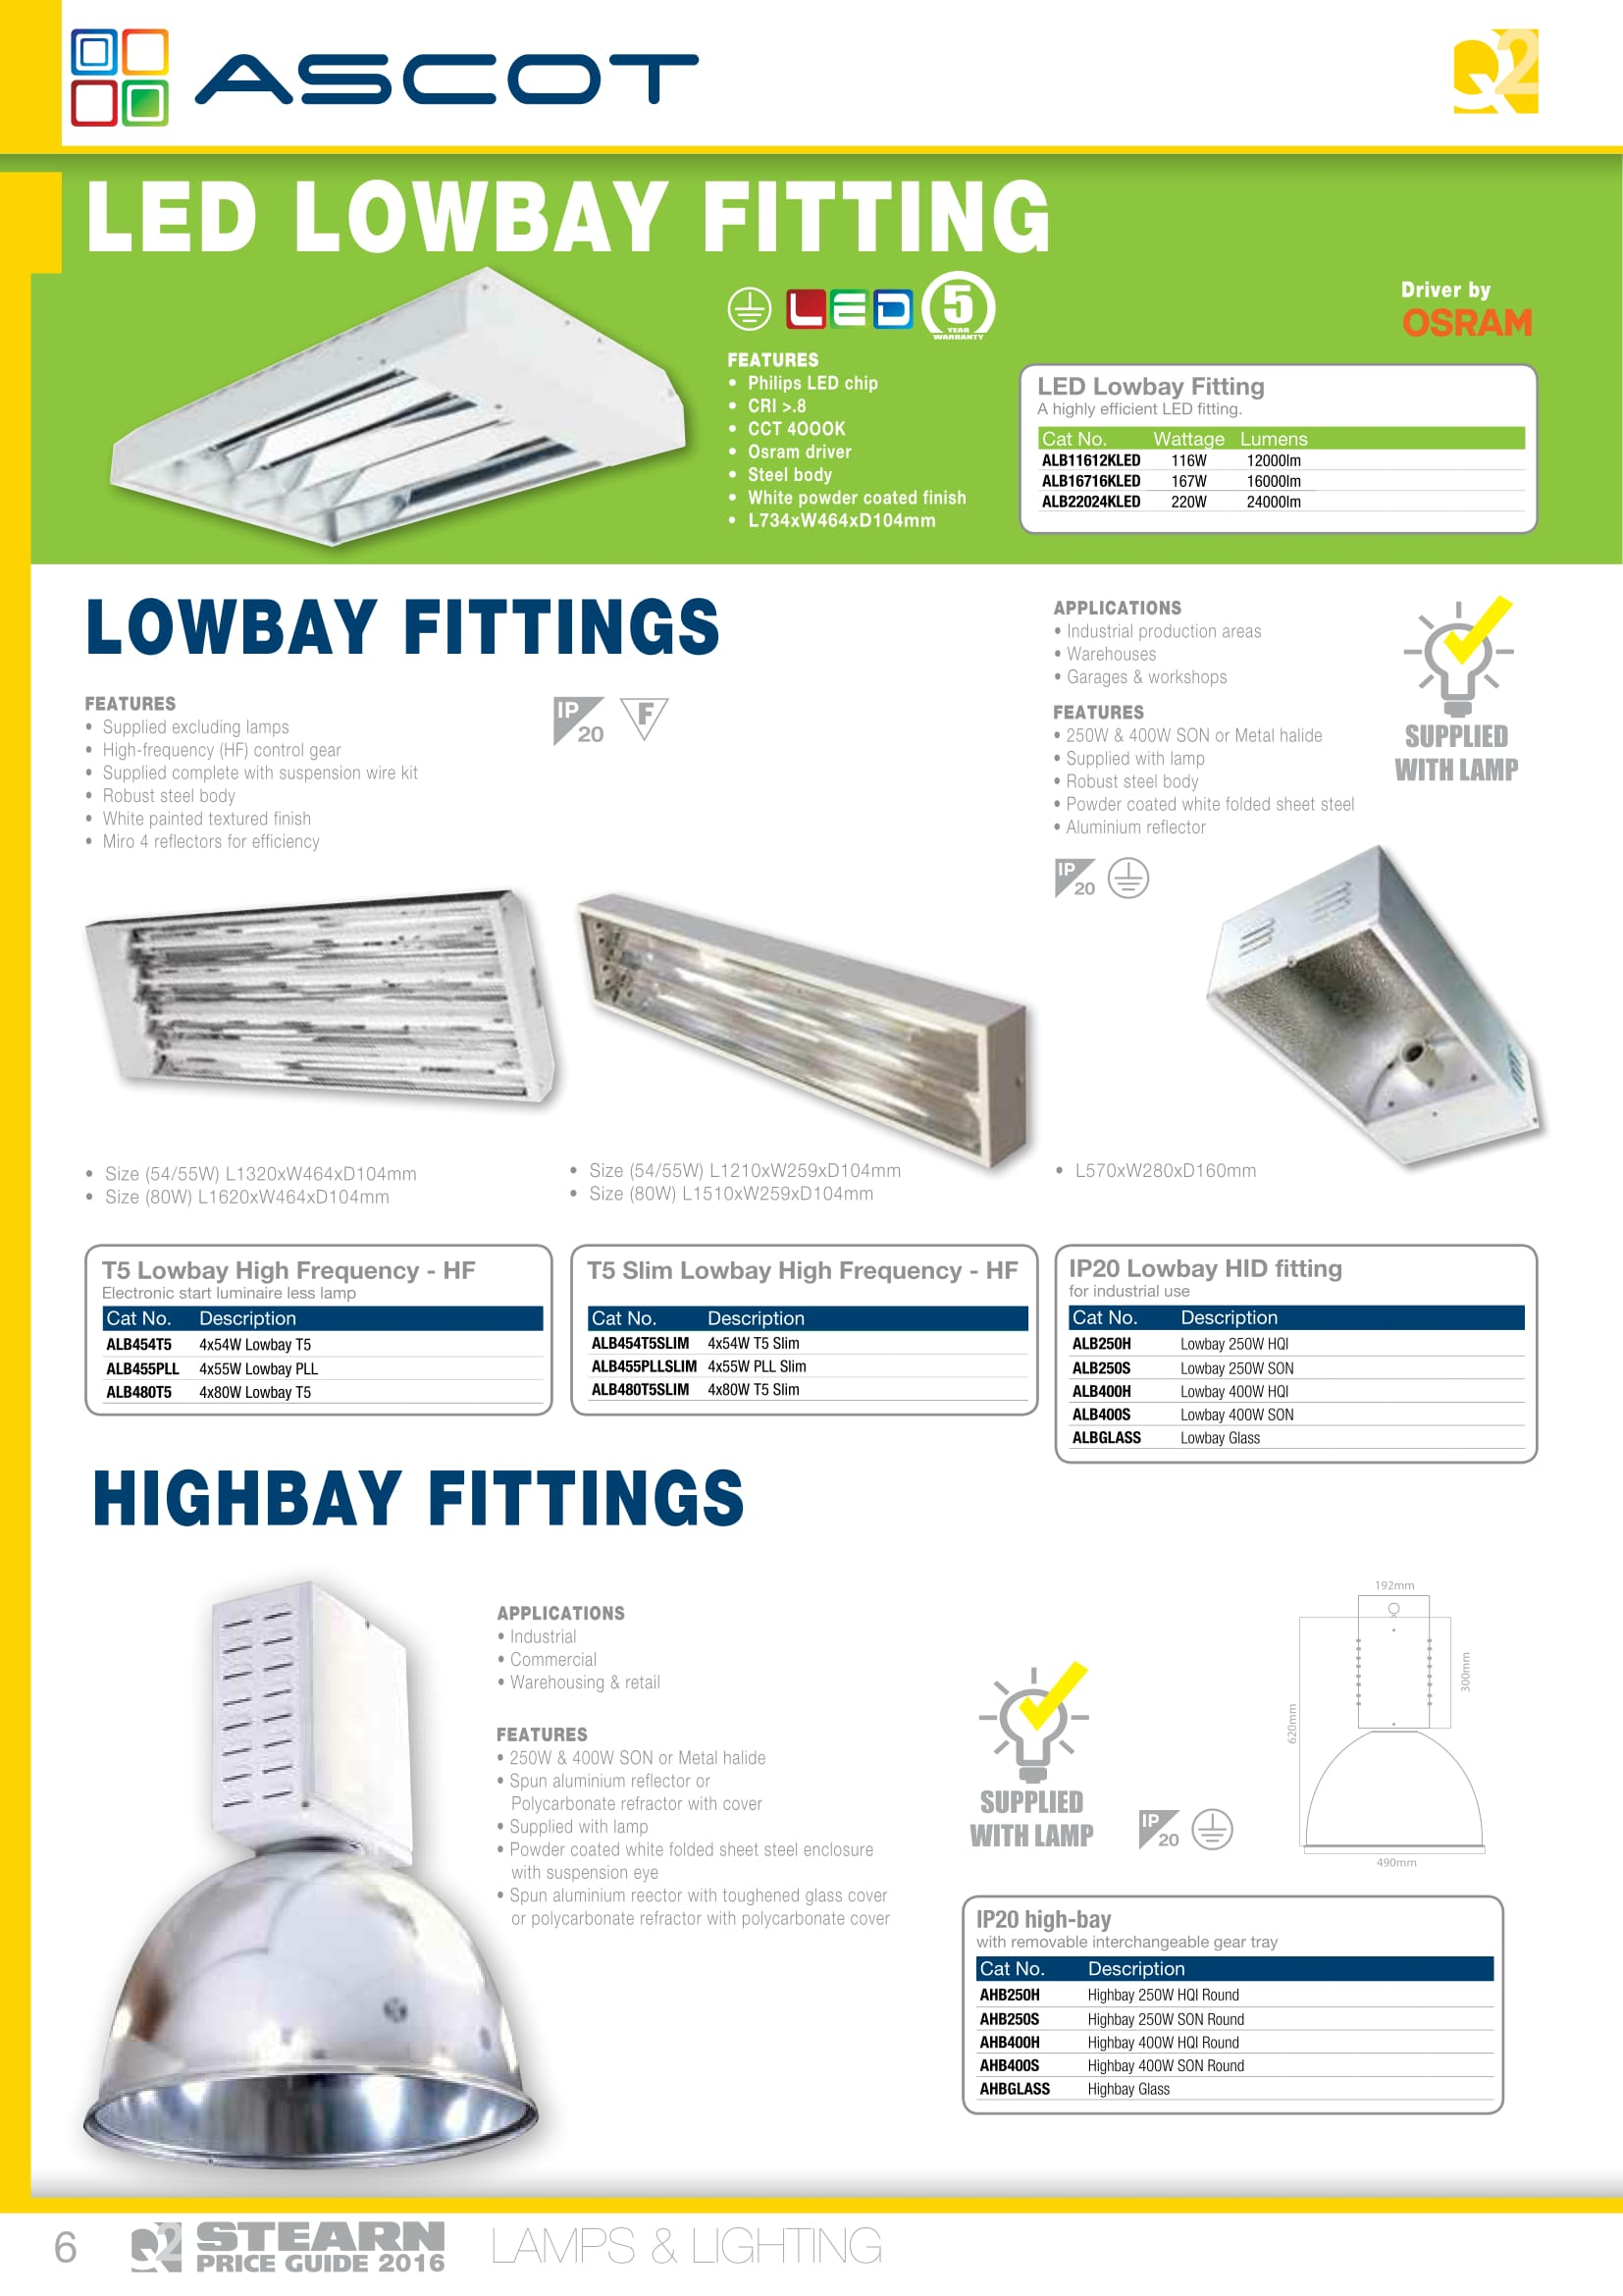
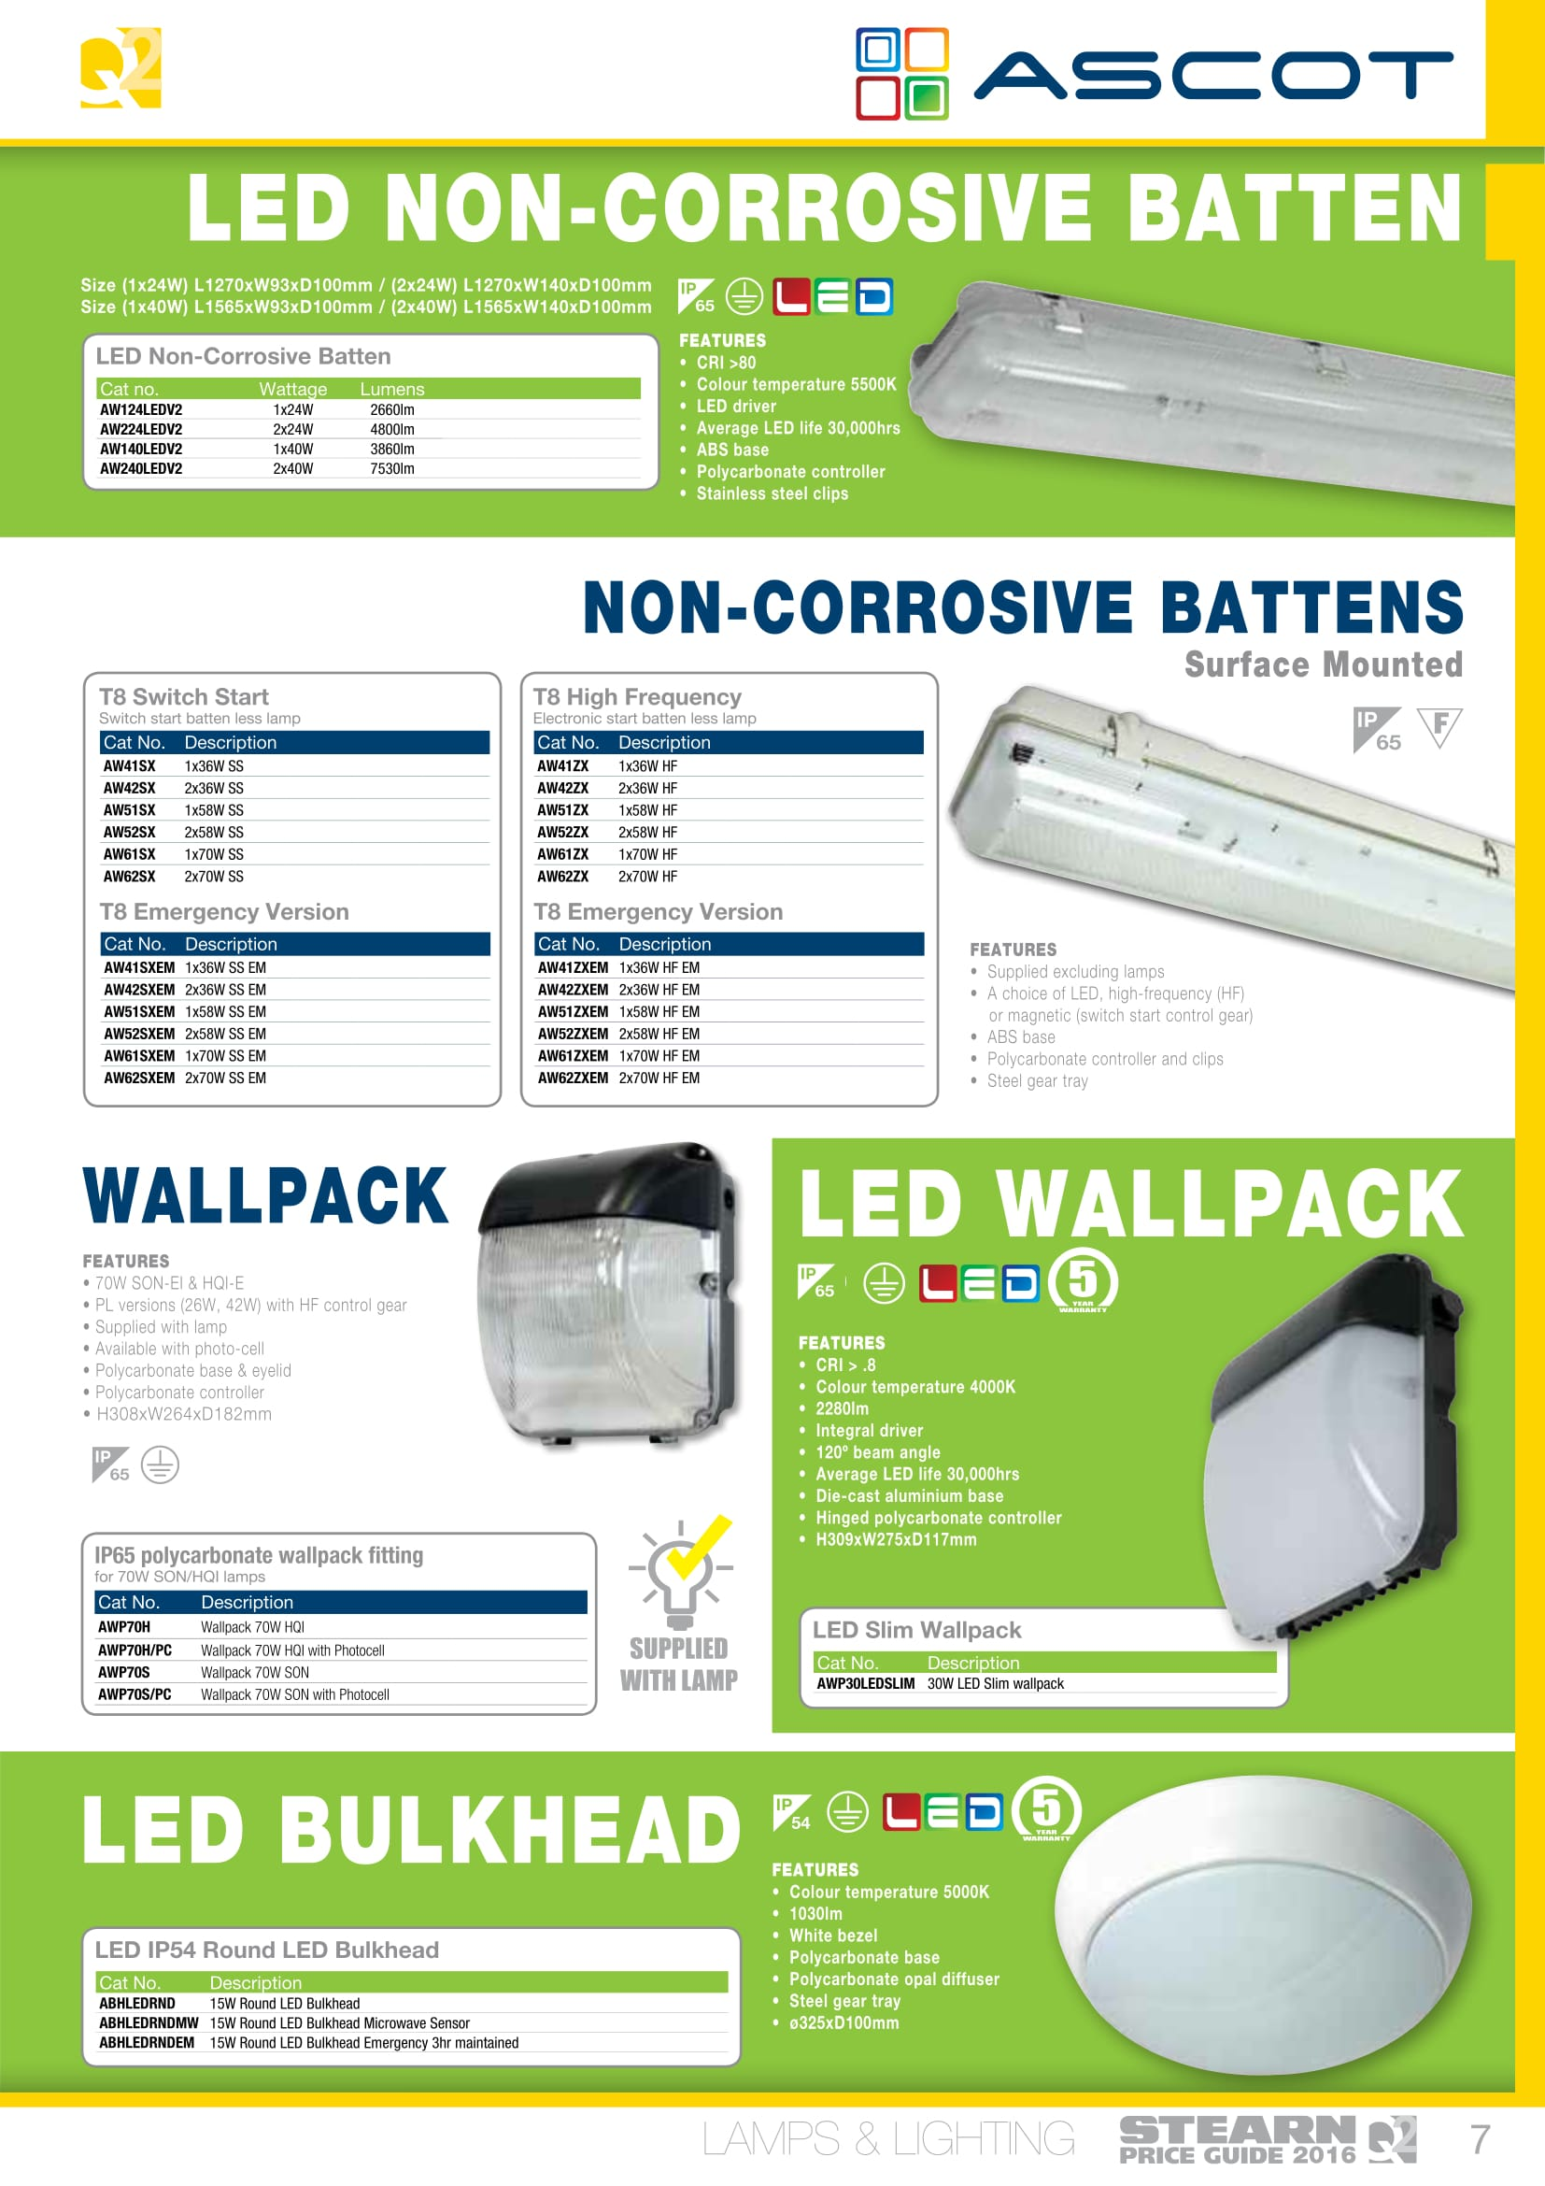
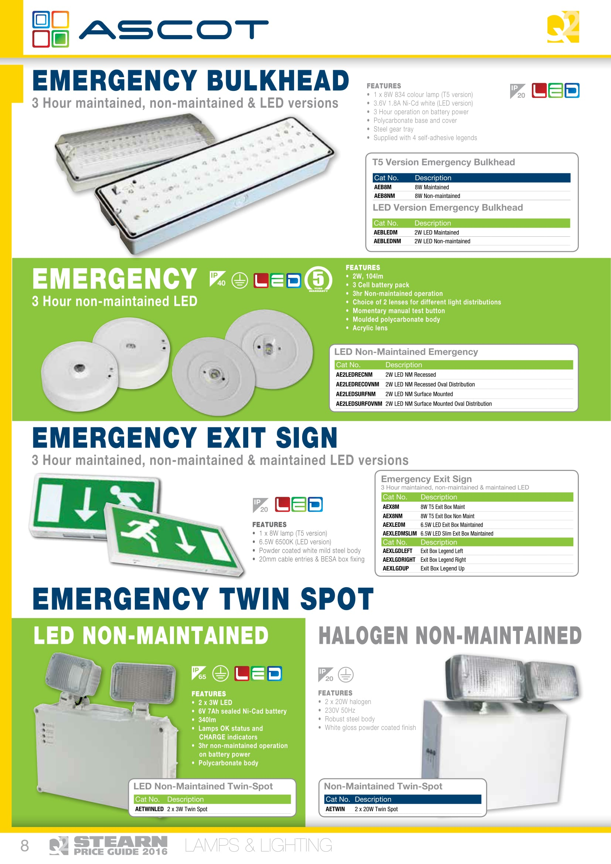
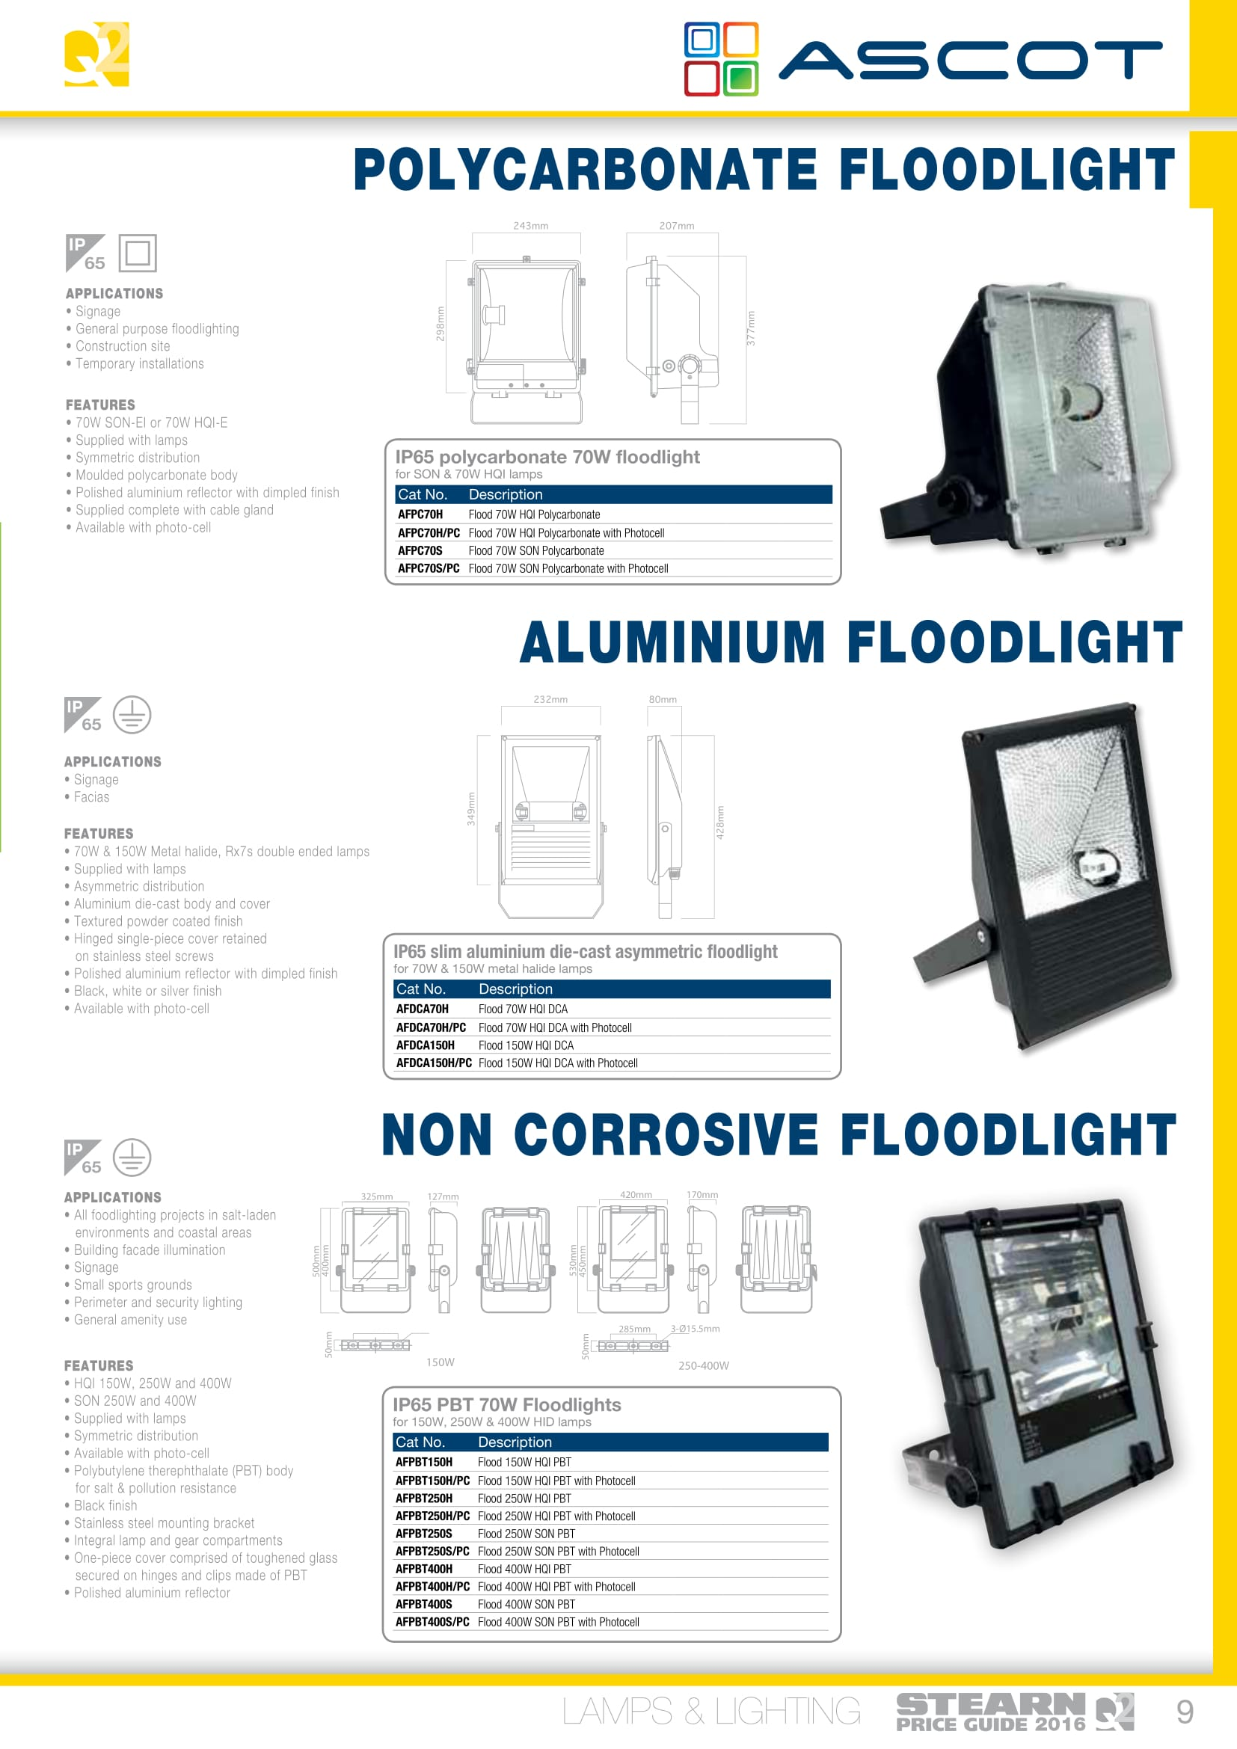
NVC TAMPER 70W OUTSIDE LIGHT REF: NTA70 HGI-DE/BK/740
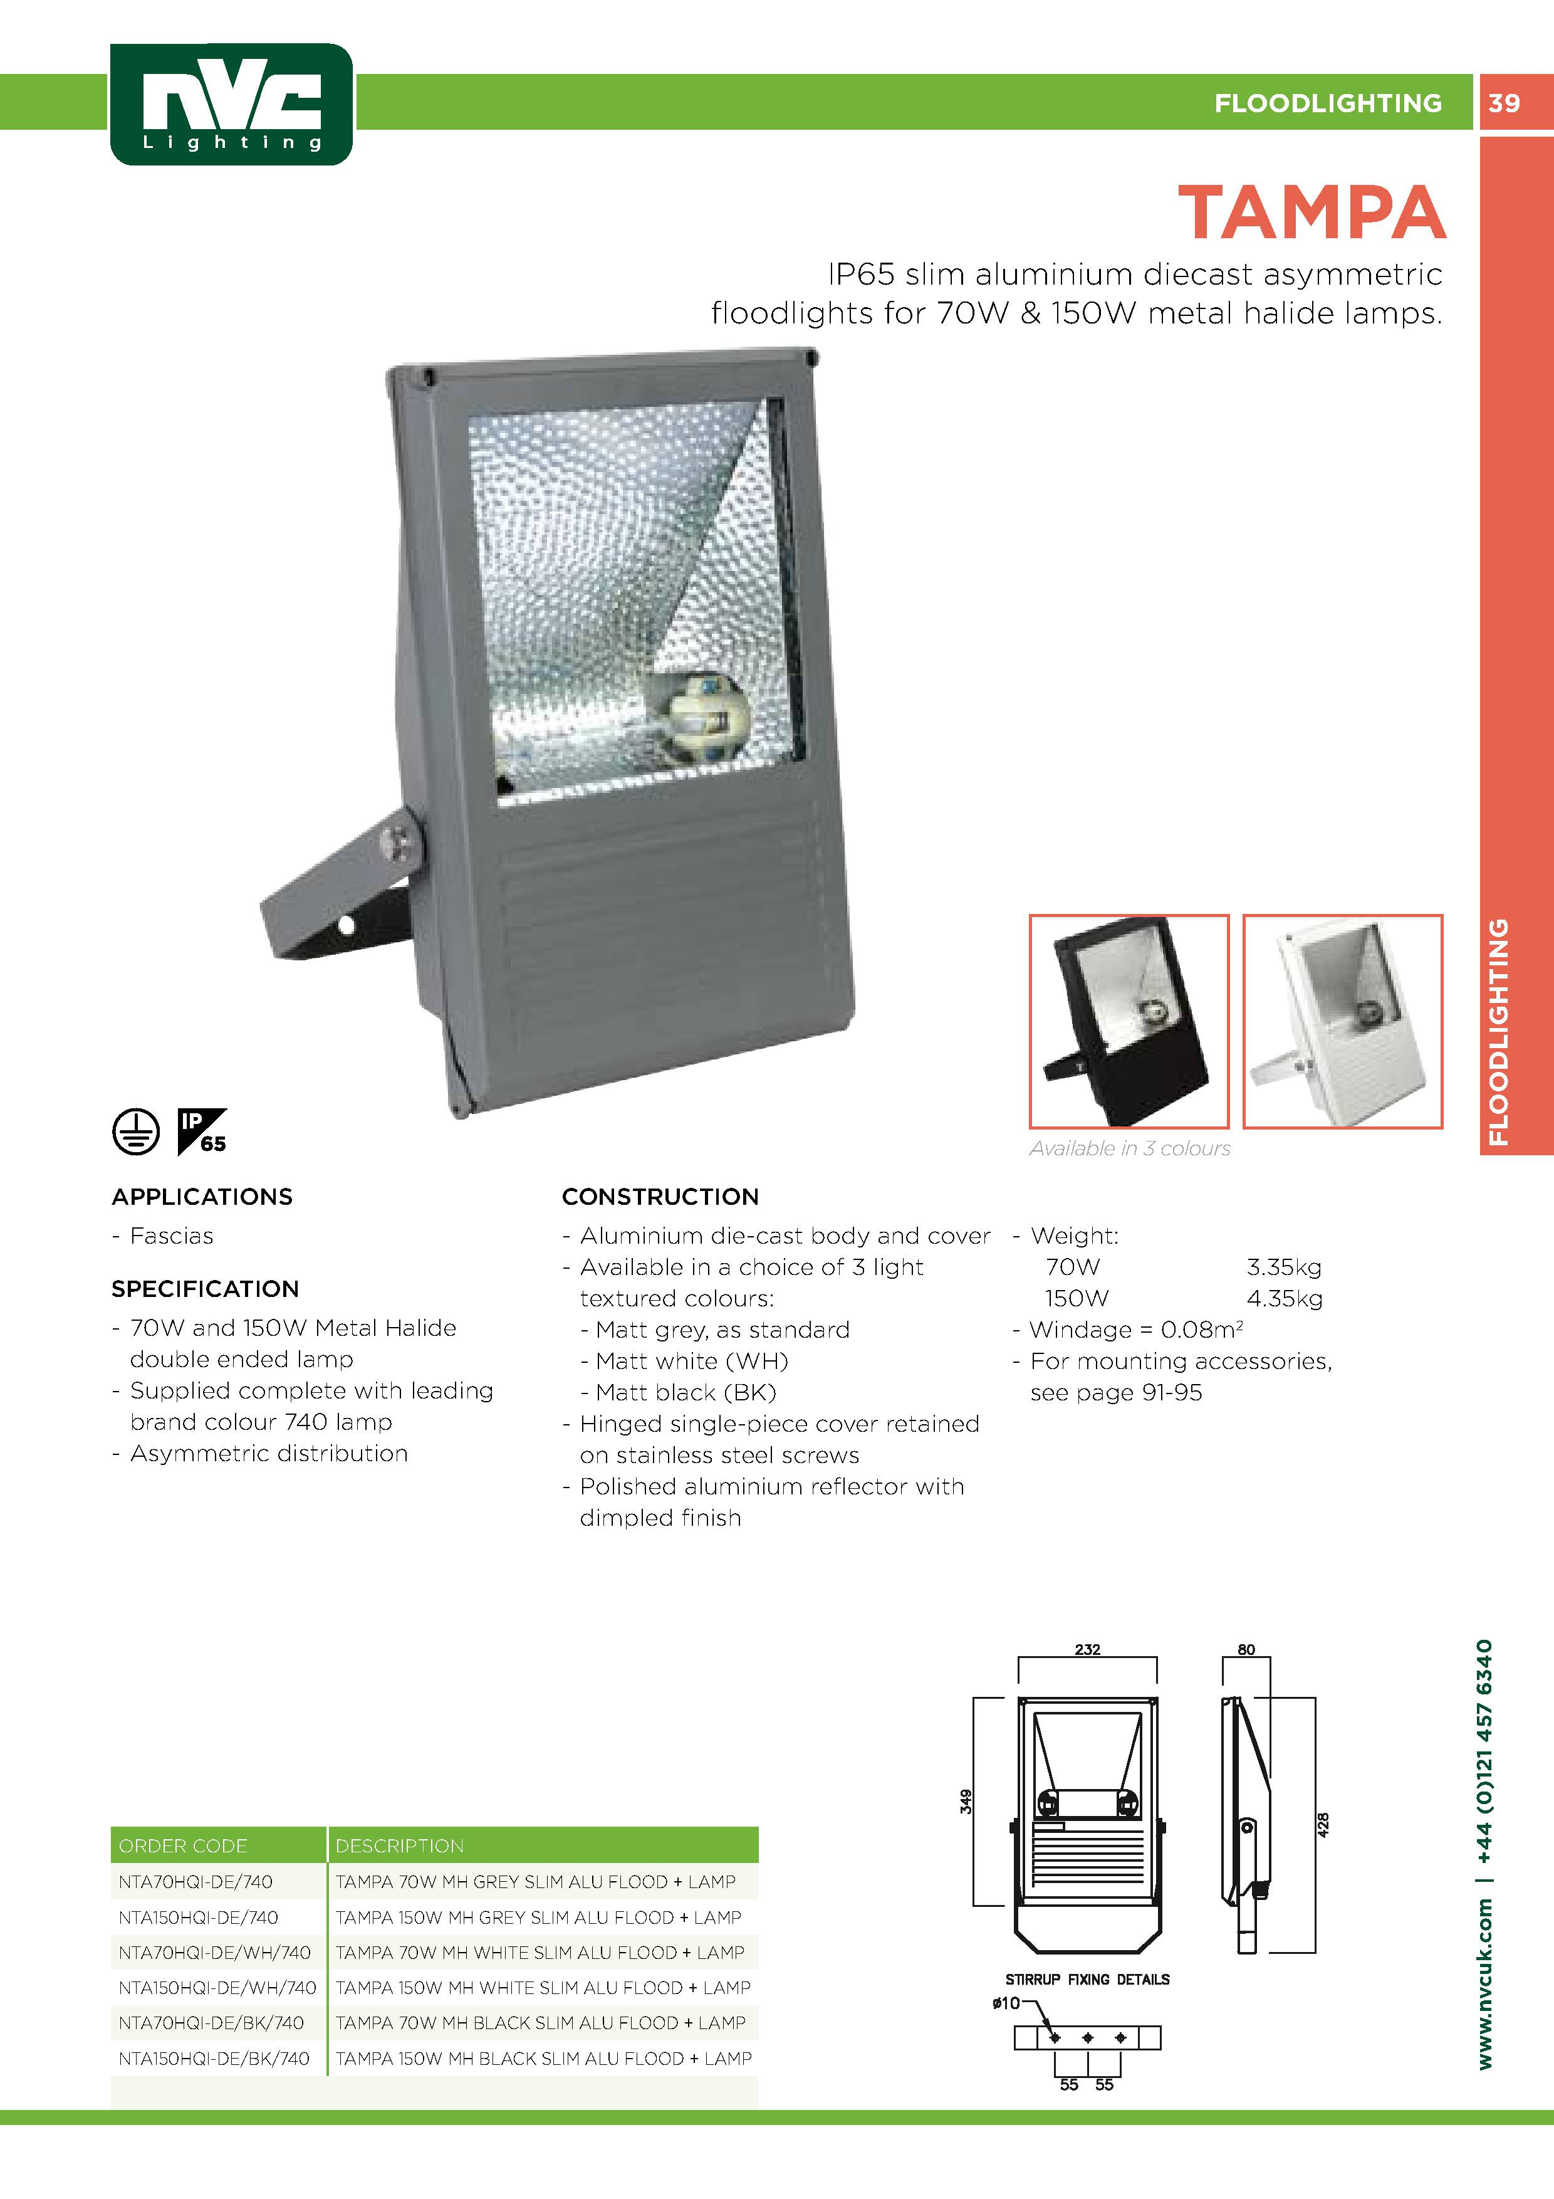
T8 FLUORESCENT LAMP 70W 1800MM WARM WHITE

THORN PP2270PRDIF PRISMATIC REF: 96217834
OSRAM LAMP ES 70W W/O IGNTR REF: NAV-E
ASCOT REF: AWP70S
FERN RND LUMIN HF 1944 & 2D REF: FHE20316R
STARTER FLU 70-125W 230-250 REF: FS125

SUPPLIER: AIB GLASGOW PH. 0141 445 6633

BELL FLUORESCENT TUBE T8 70W DAY REF: 05572/05571
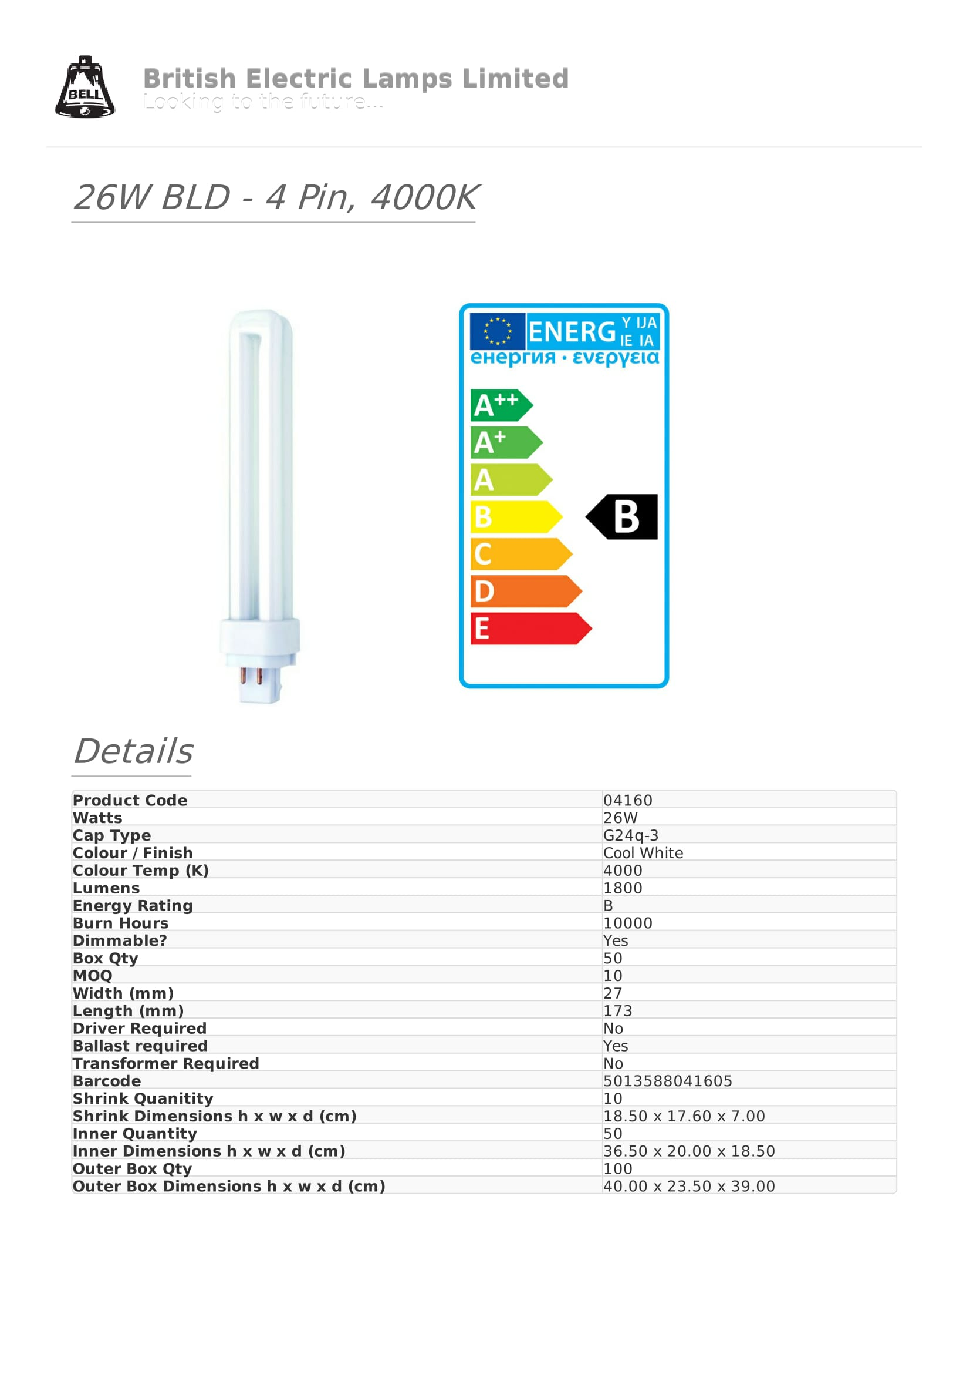

ACEL STARTER FLUORESCENT 70-125W REF: AC4992
ACEL STARTER FLUORESCENT 4-810W REF: AC4990
BELL FLUORESCENT TUBE T8 58W DAY REF: 05565
ACEL ROUND 16W HF OPAL REF: AC41361
ACEL BATTEN SINGLE SS 70W WHI REF: AC4006
ACEL PRISMATIC DIFFUSER SGL 6FT REF: AC4046
ACEL 250W HQI-T LOW BAY REF: AC49087
ACEL BATTEN SINGLE SS 70W WHI REF: AC4006
ACEL PRISMATIC DIFFUSER SGL 5FT REF: AC4044
FERN EM B/HD 1965 REF: FHBL559-W-CL-EM
BELL CFL BLD 4-PIN 26W 4000K REF: 04160

SUPPLIER: ELECTRIC CENTRE GREENOCK PH. 01475 552500

S E C T I O N S I X.

Distribution Panels/Parts List

S E C T I O N S E V E N.

Fire Alarm Panel/Parts List

SURFACE CALL POINT REF: 40-SCP2R
BANSHEE RED SOUNDER C/W STROBE REF: CB-IR
4-ZONE FIRE PANEL REF: MAG4P
12V 7.AH BATTERY REF: BAT7

SUPPLIER: HOLLAND HOUSE GREENOCK PH. 01475 784331

S E C T I O N E I G H T.

Miscellaneous

KEY SWITCH SPUR RED SURFACE REF: VMS/R

SUPPLIER: HOLLAND HOUSE GREENOCK PH. 01475 784331

METALCLAD 1-GANG BLANK PLATE REF: NS1:1
ACEL SURFACE FRONTPLATE 3-GANG REF: AC1612
20A 2-WAY SWITCH MRKD EM TEST REF: AC1658
ACEL 1-WAY SP SWITCH MODULE 10A REF: AC1650
ACEL COMMON DETECTOR BASE REF: AC5209
ACEL 2 WIRE 5 IN 1 DETECTOR REF: AC4044
ACEL TERMINAL BOX 20MM GALVANISED REF: AC7900
ACEL THROUGH BOX 20MM GLAVANISED REF: AC7920
ACEL U BOX 20MM GALVANIASED REF:AC7920
HAGER CEILING ROSE 3-PIN 6A REF: PCR2000
ACEL PLATE SWITCH 3-G 2-WAY REF: AC1016

SUPPLIER: ELECTRIC CENTRE GREENOCK PH. 01475 552500

CONTAC PLATE SWITCH 2-G 2-WAY 1-A REF: A2722
KLICK CEILING ROSE 3-PIN REF: PCR2000

SUPPLIER: AIB GLASGOW PH. 0141 445 6633

