Miscellaneous

2G 35MM SWITCH & SOCKET BOX REF: PSB235
1G 35MM SWITCH & SOCKET BOX REF: PSB135
MK GRID MFRONTPLATE 12 MODULE REF: K3502ALM
MK GRID BOX 9&12 GANG SURFACE C/W KO REF: K8895ALM
MK GRID FRAME 4G 4 MODULE REF: K3704
MK GRID SWITCH 1 W DP 20A REF: K4896

MK GRID SWITCH 2 W DP 20A REF: K4892
MK GRID SWITCH 1 W DP KEY REF: K4917
MK METALCLAD SWITCH 1 GANG 2 WAY SP 10A REF: K3591
MK GRID BLANK INSERT 1 MODULE REF: K4880
MK GRID FRONTPLATE 1 MODULE REF: K3491
MK GRID BOX 1&2GANG 40MM SURFACE KO REF: K8891
MK GRID FRAME 1G 1 MODULE REF: K3701
20MM GALVANISED CONDUIT REF: 20CONG
CAPITAL CEILING ROSE 3 PIN C/W WHI REF 5001
GEWISS ENCLOSURE REF: GW44207

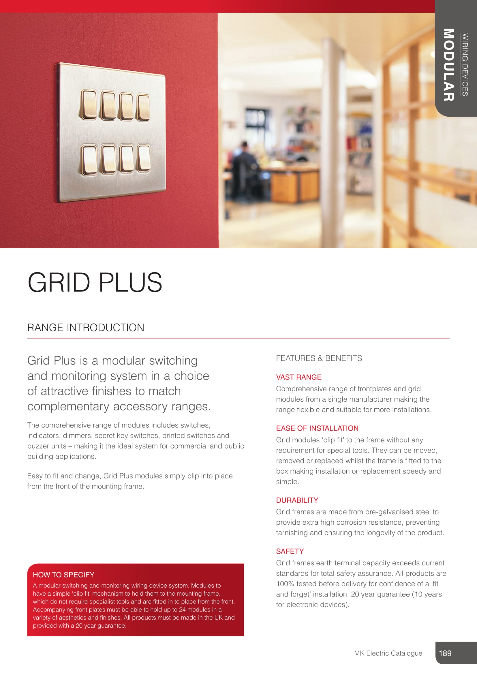

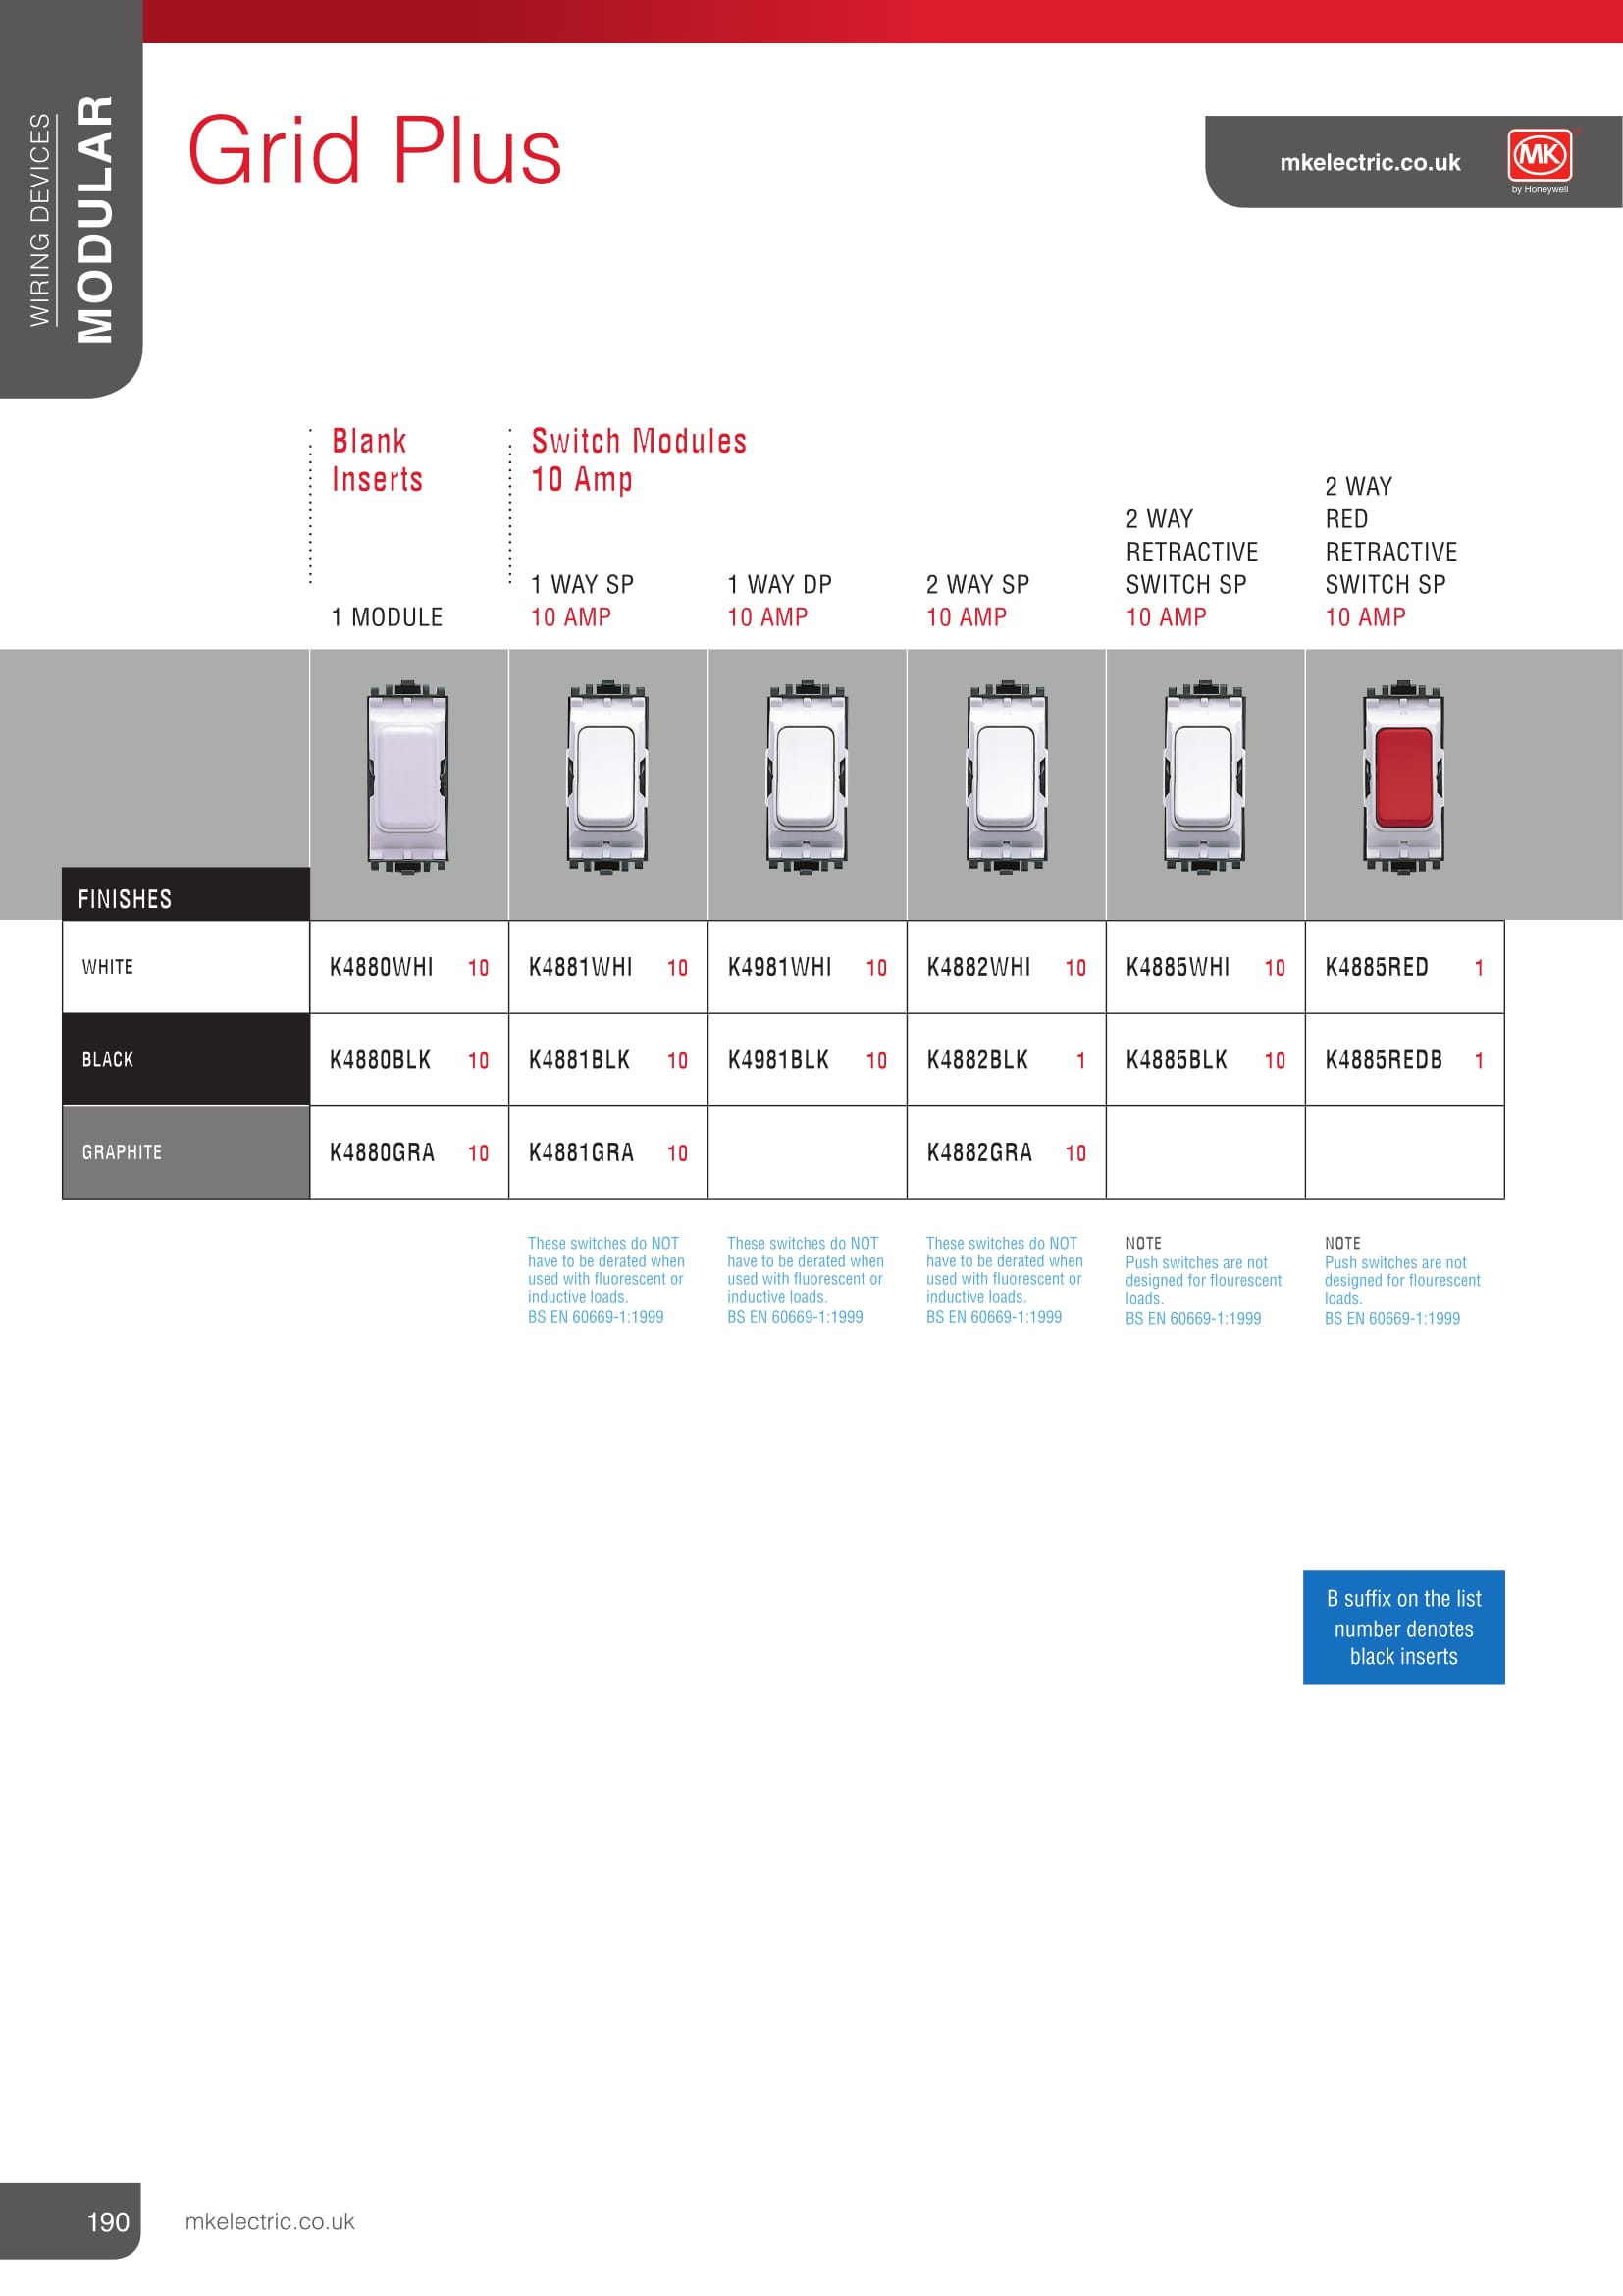
S
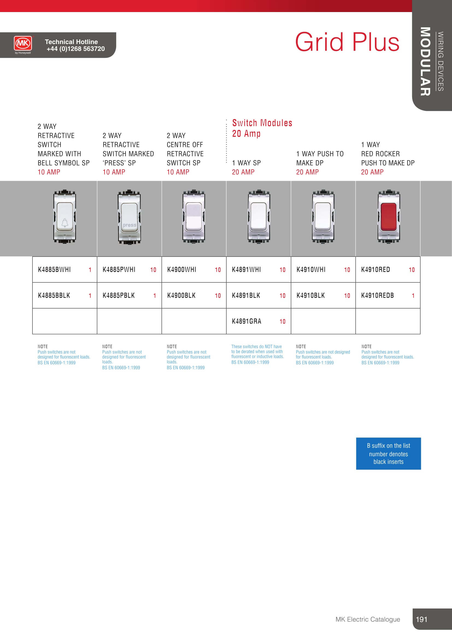

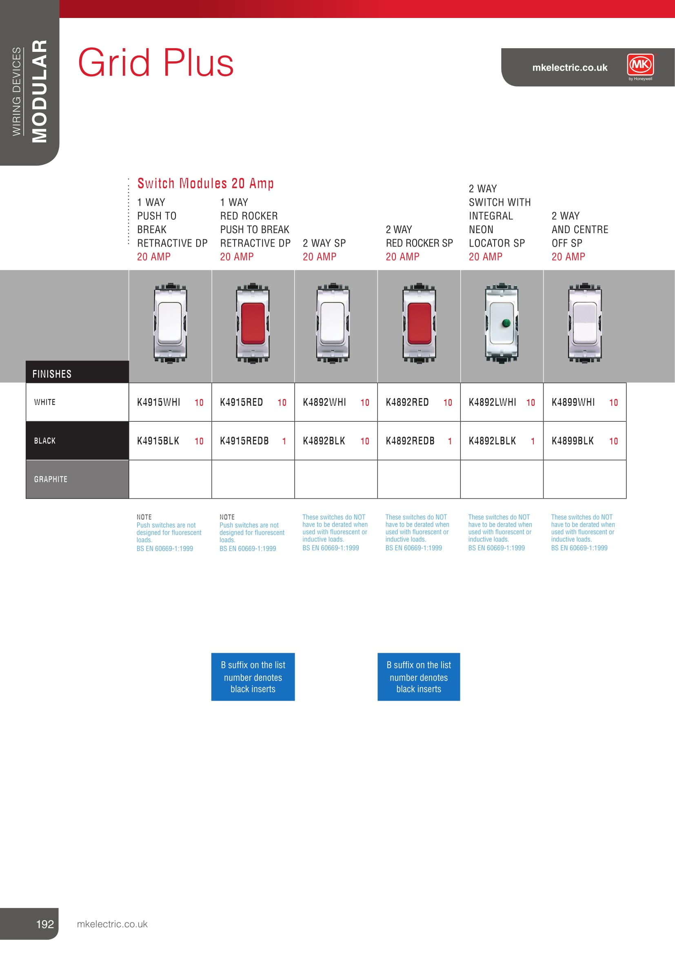

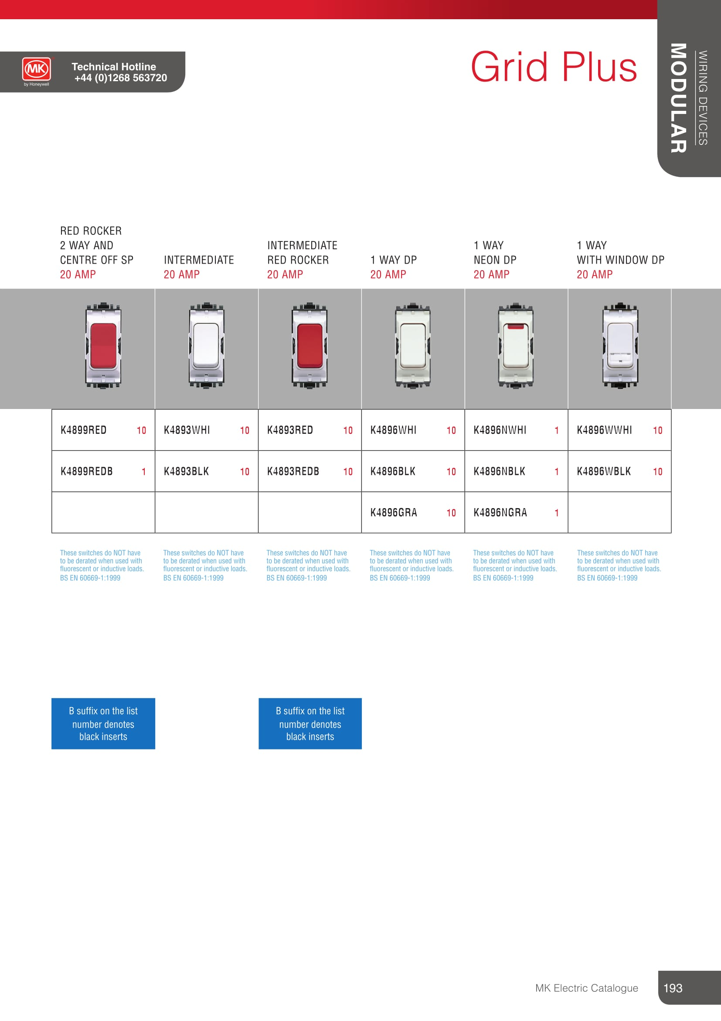

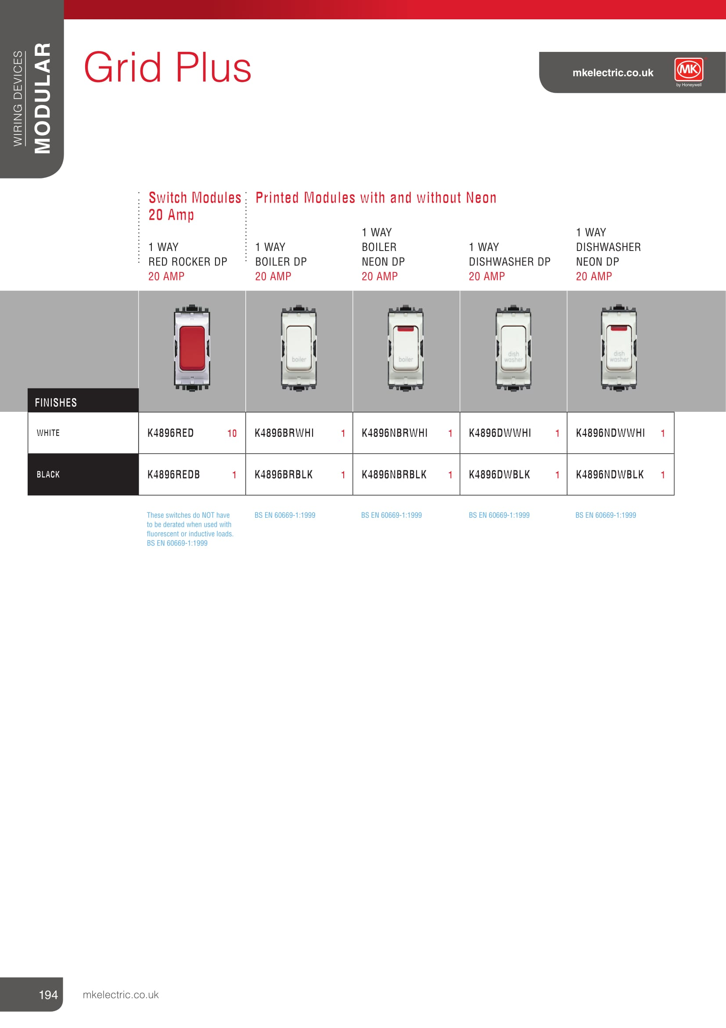
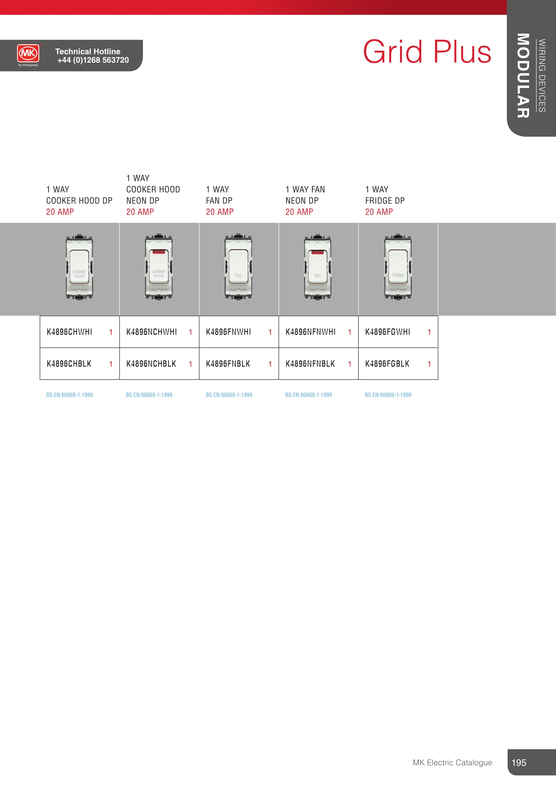

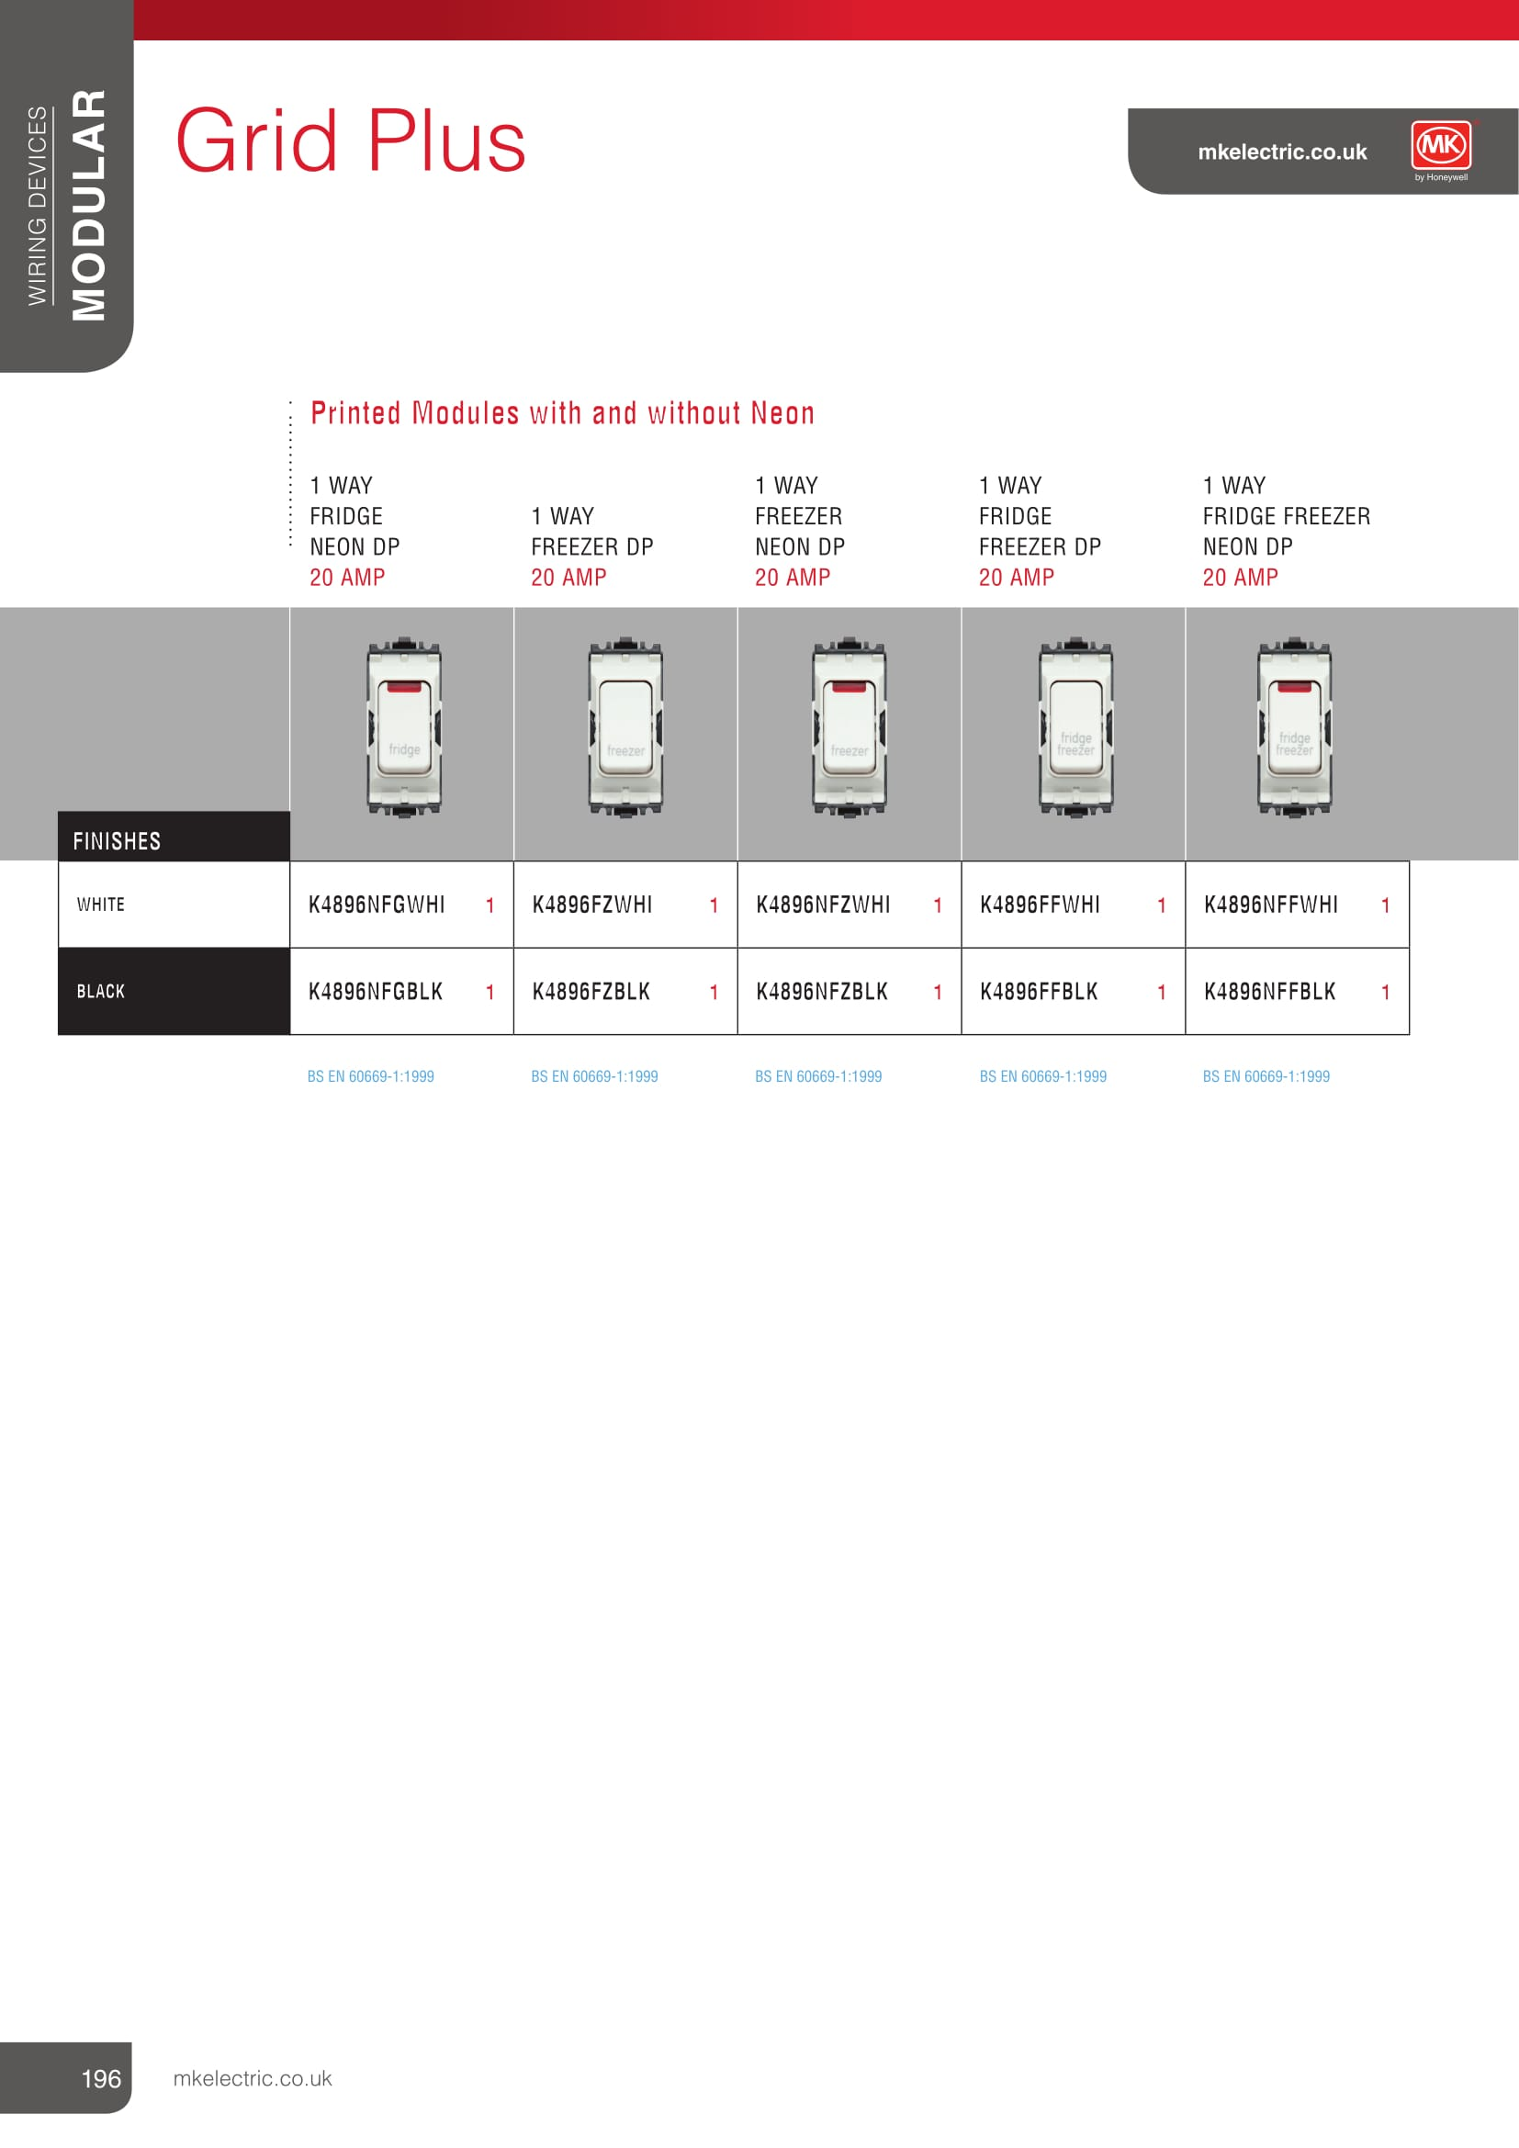

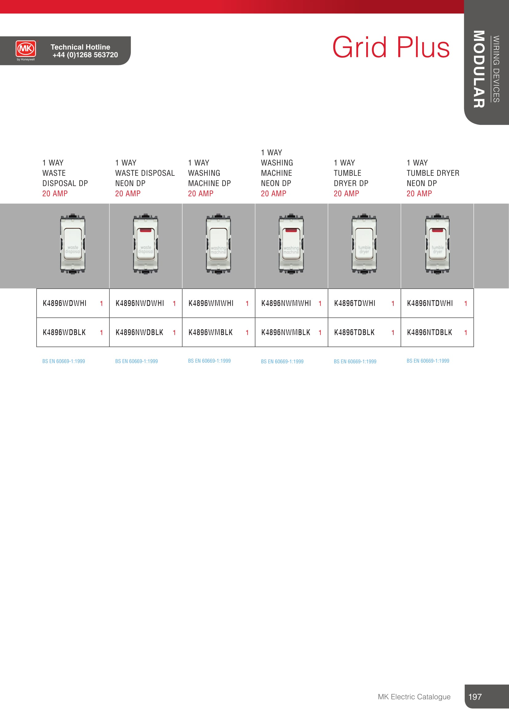

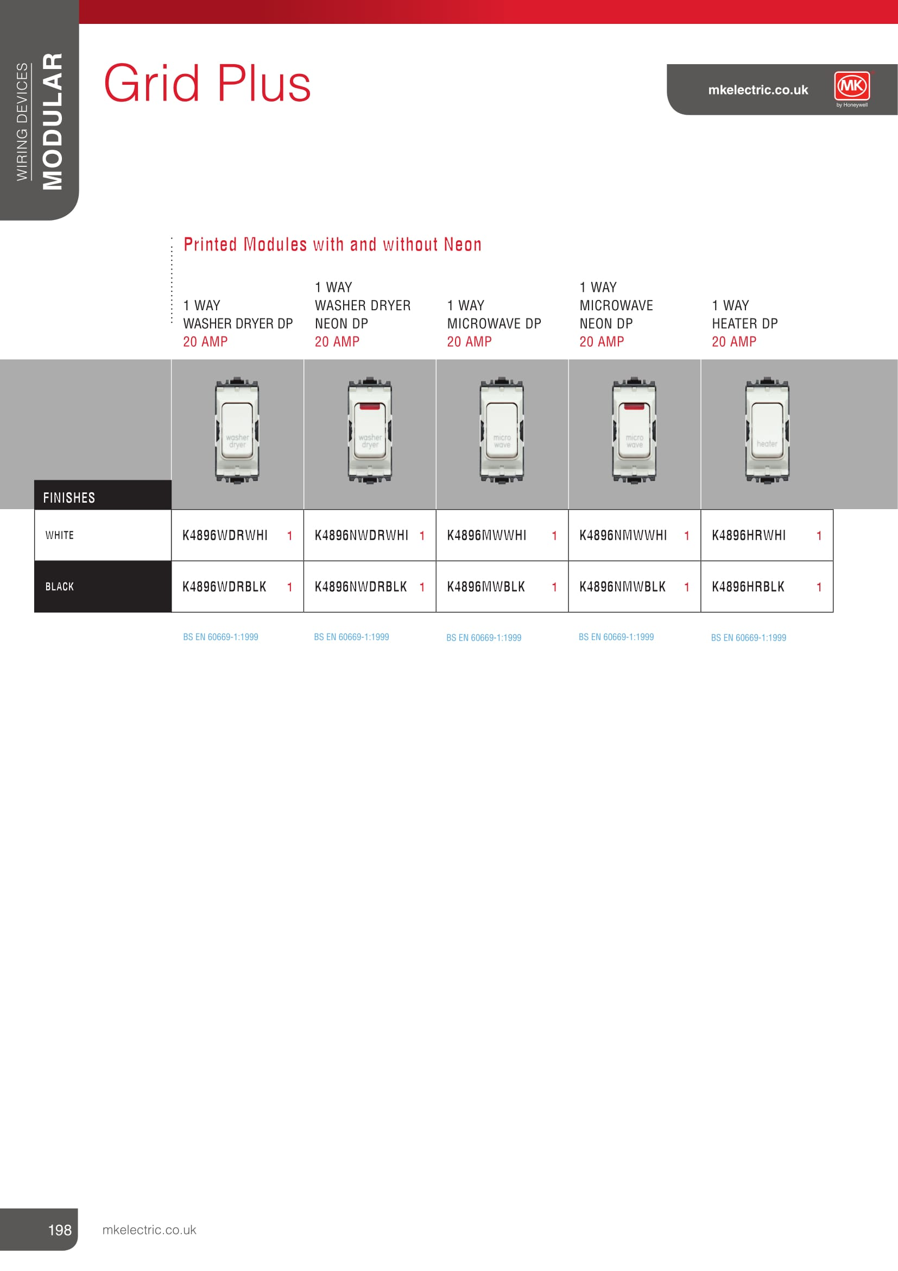

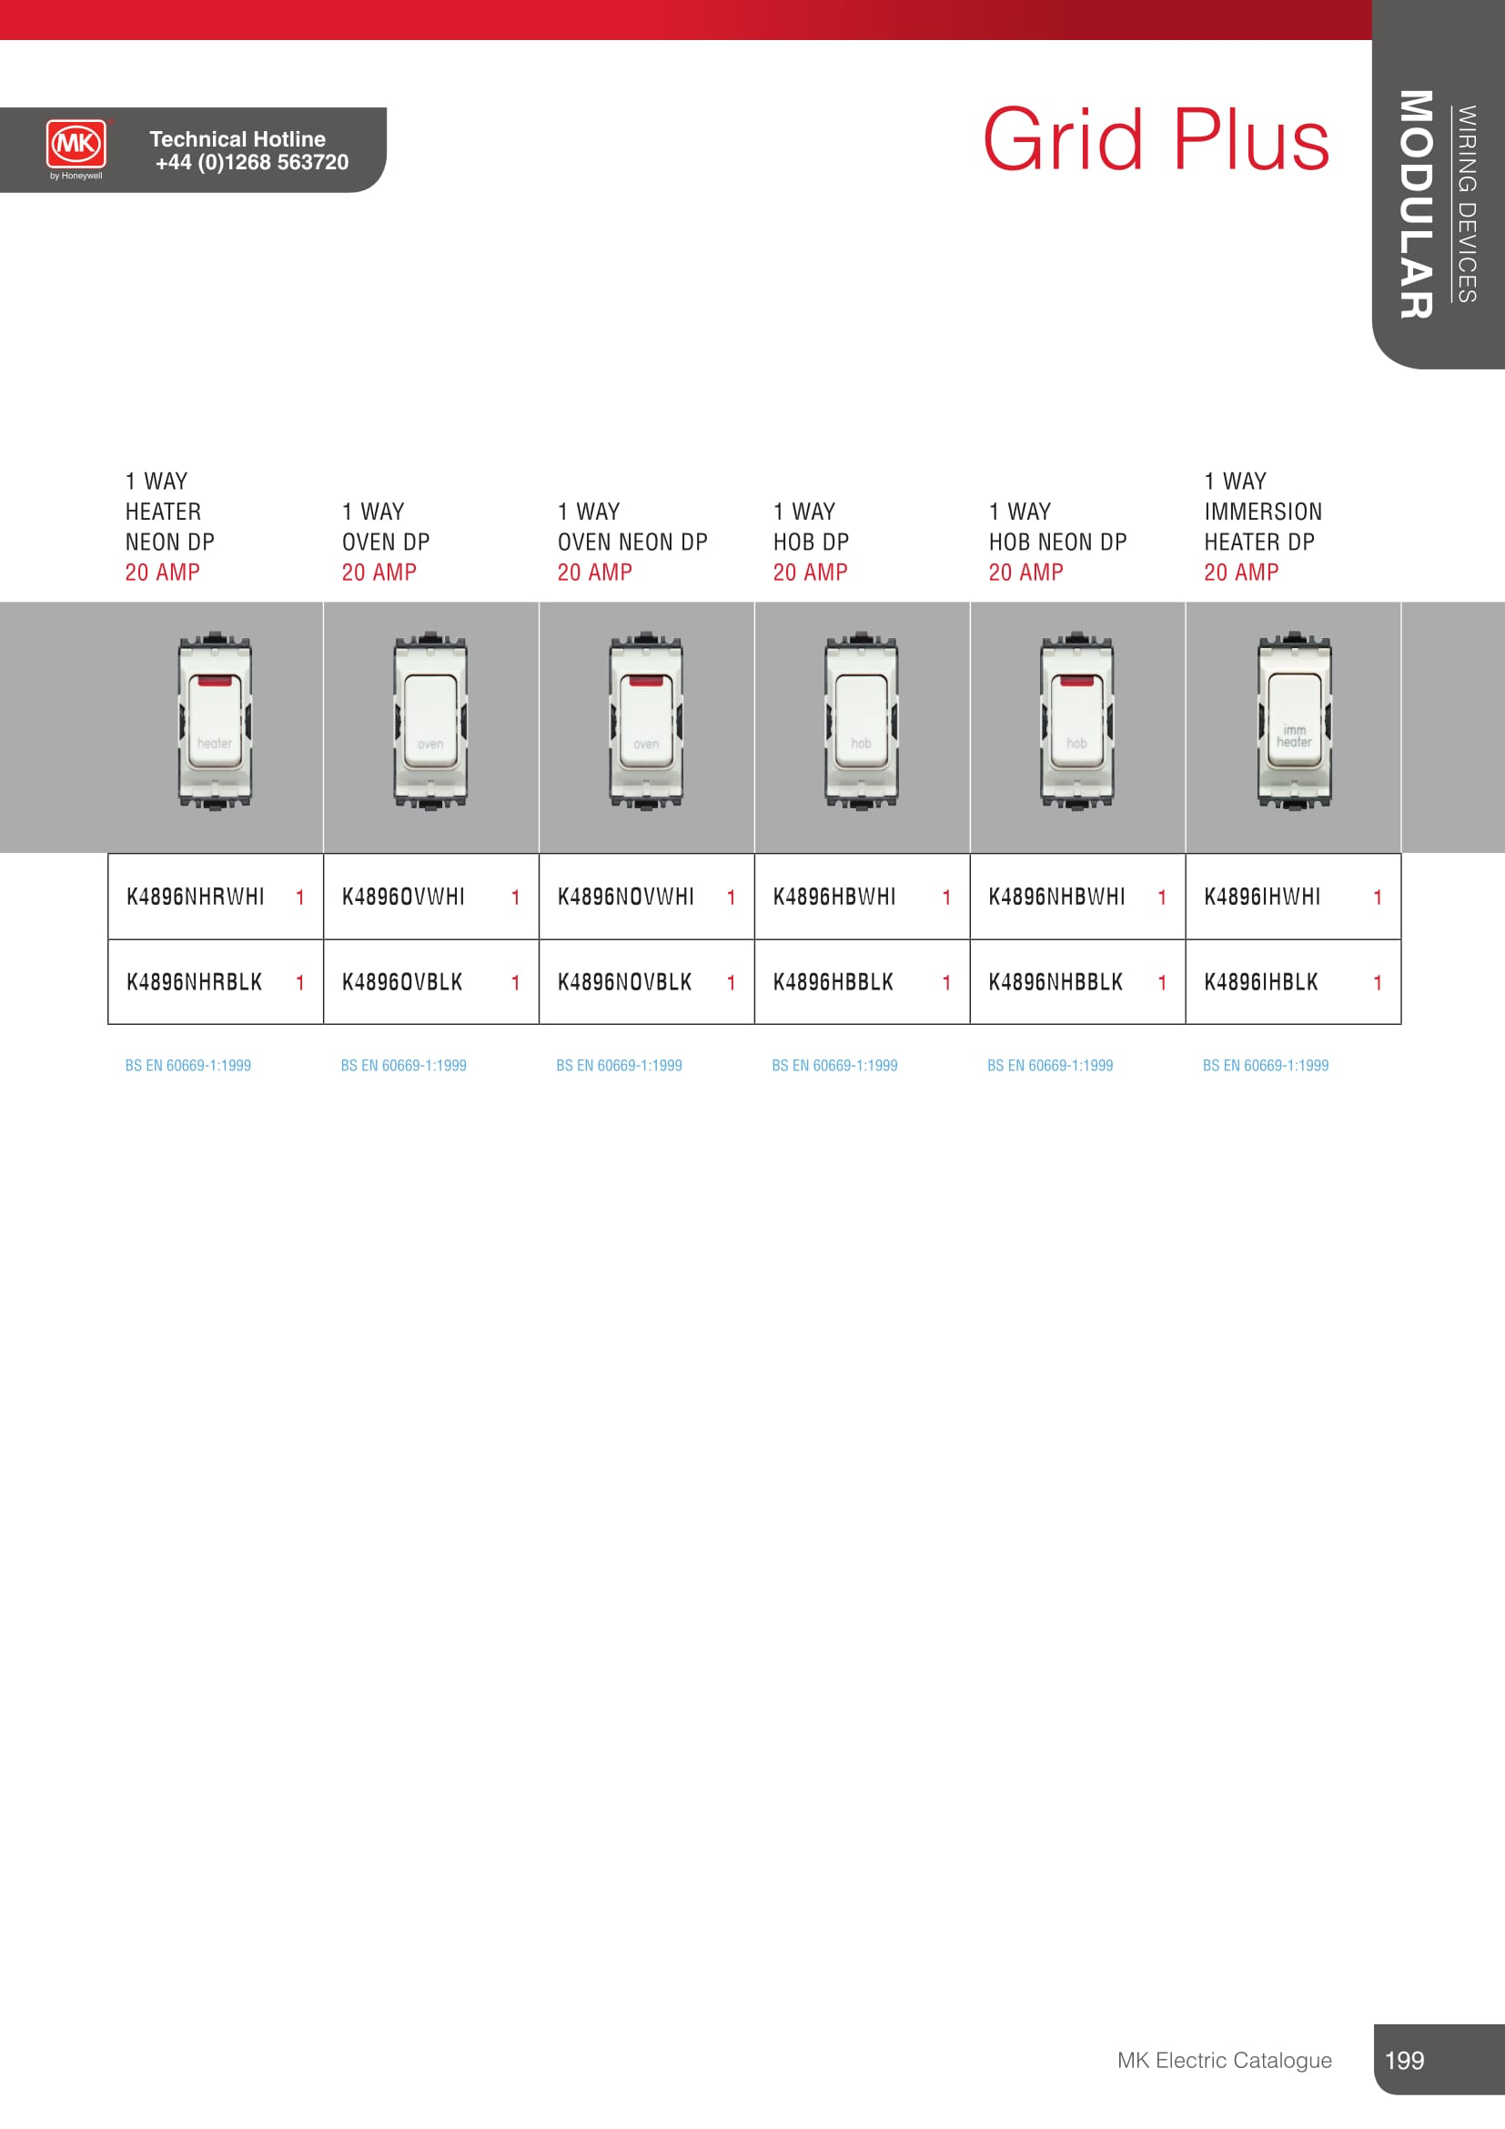

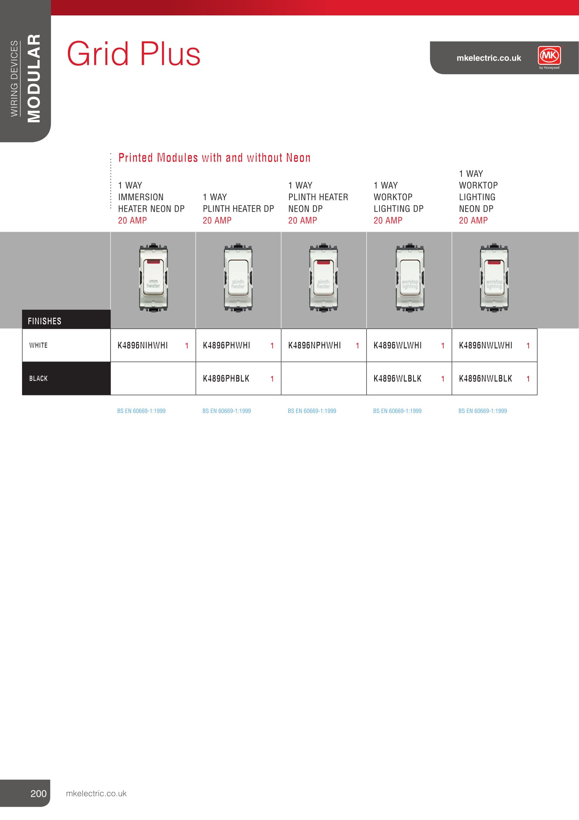

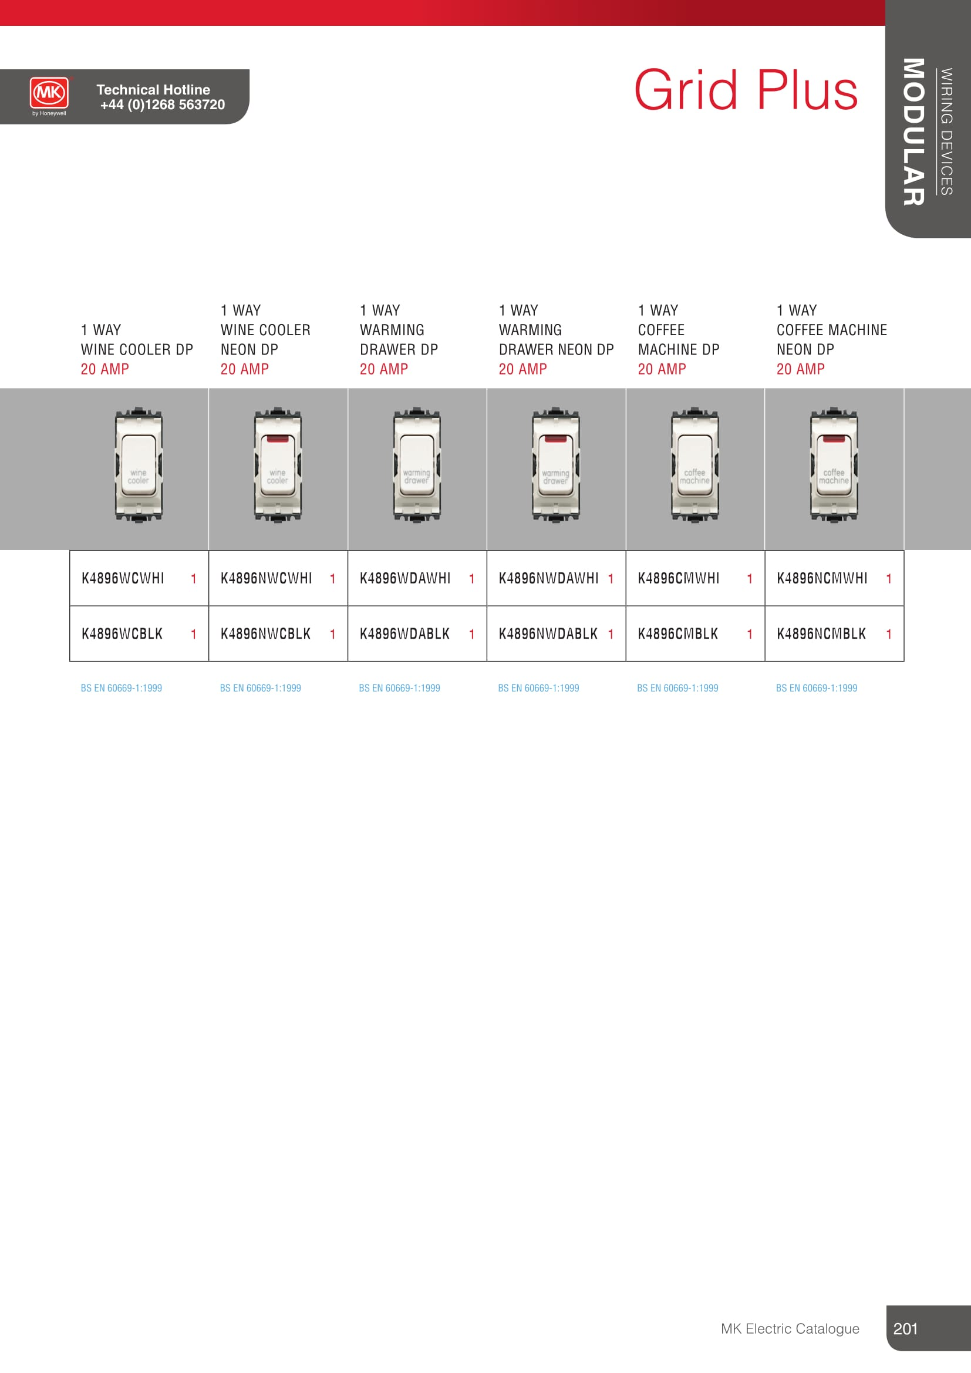

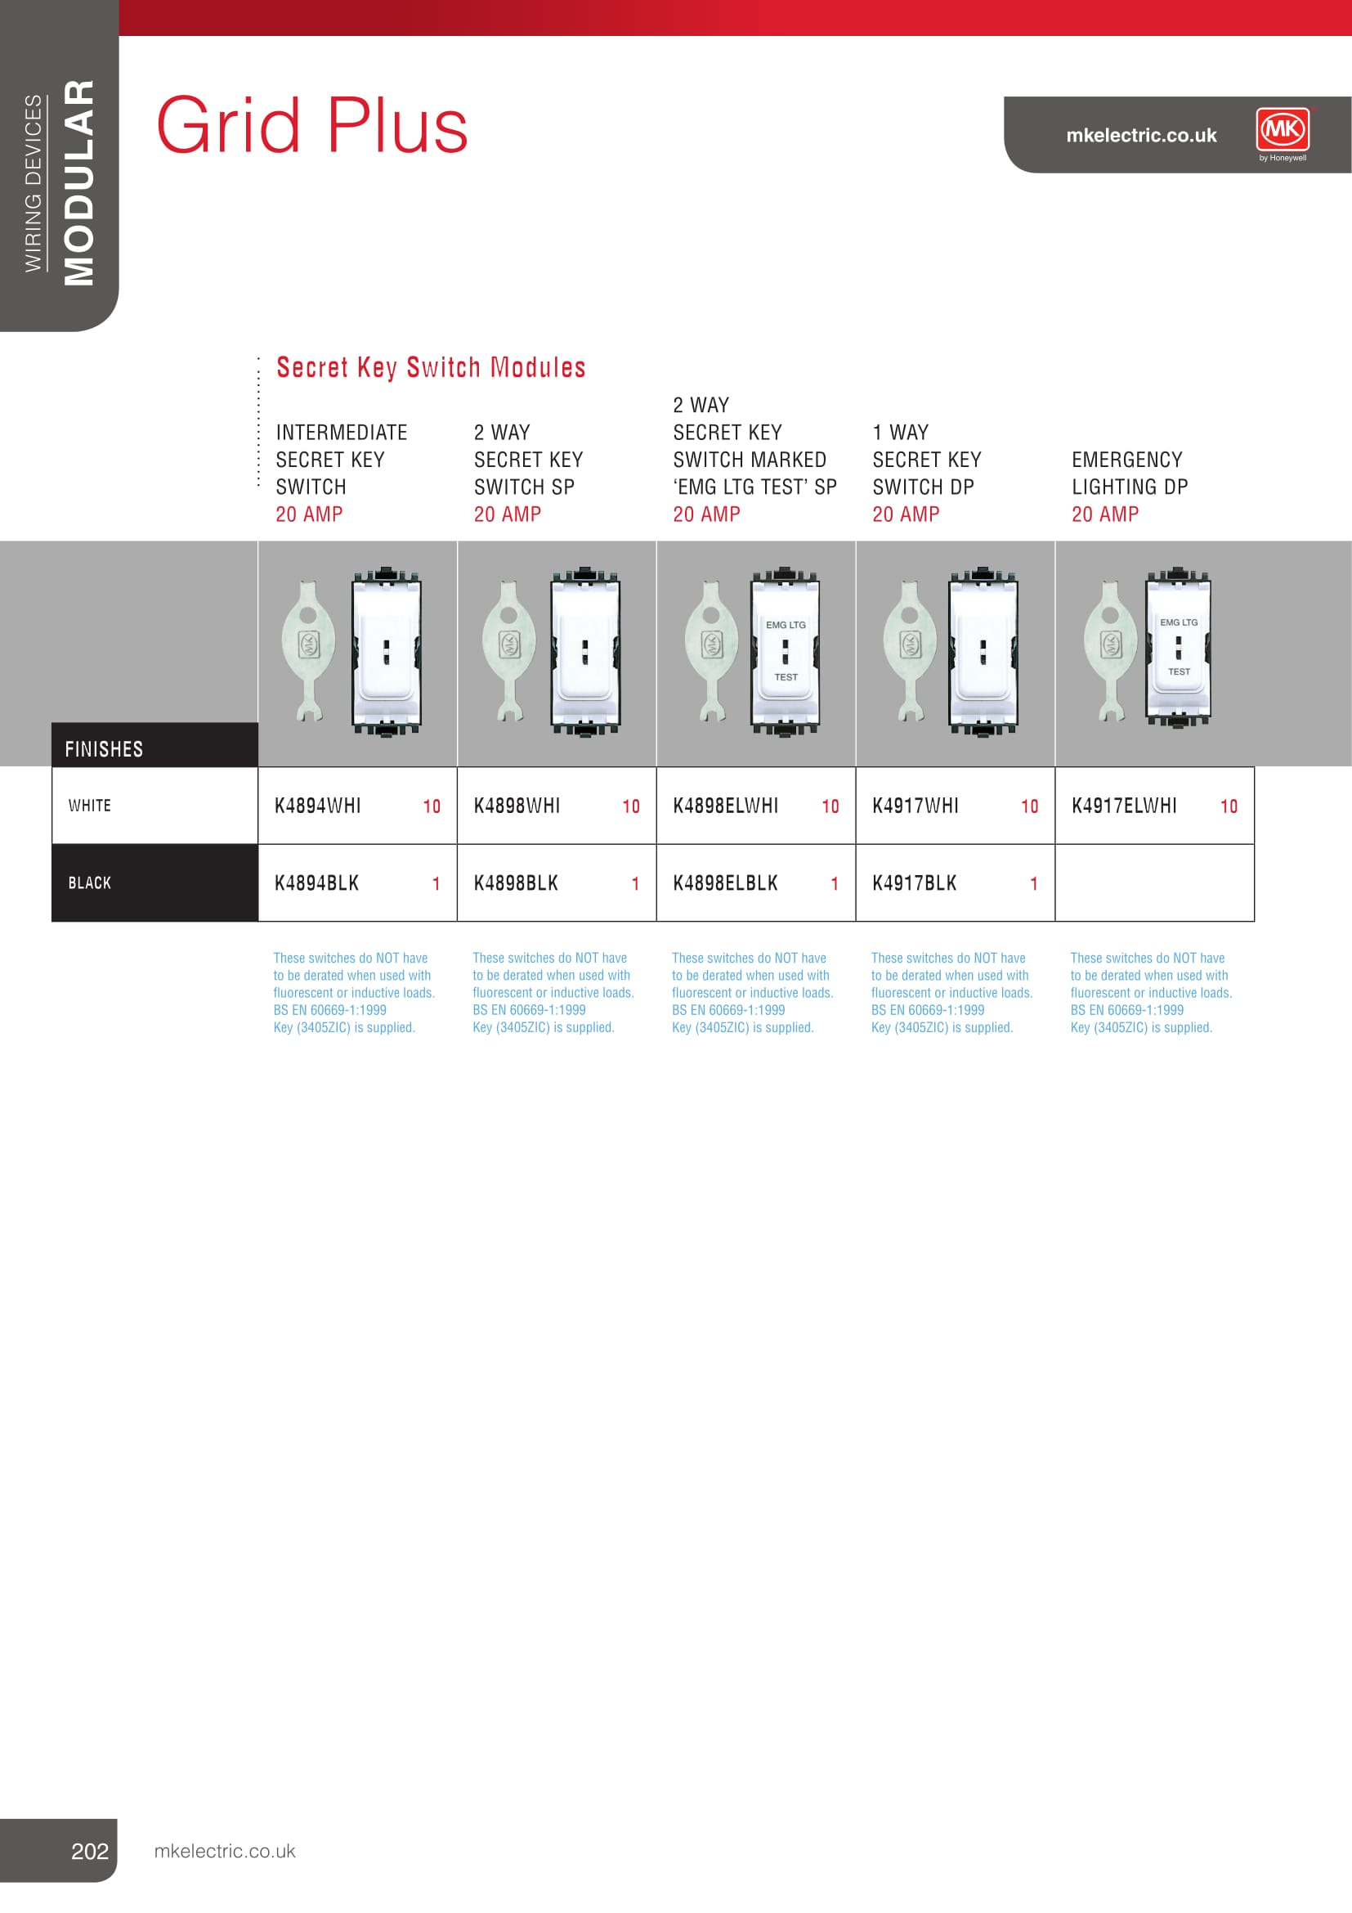

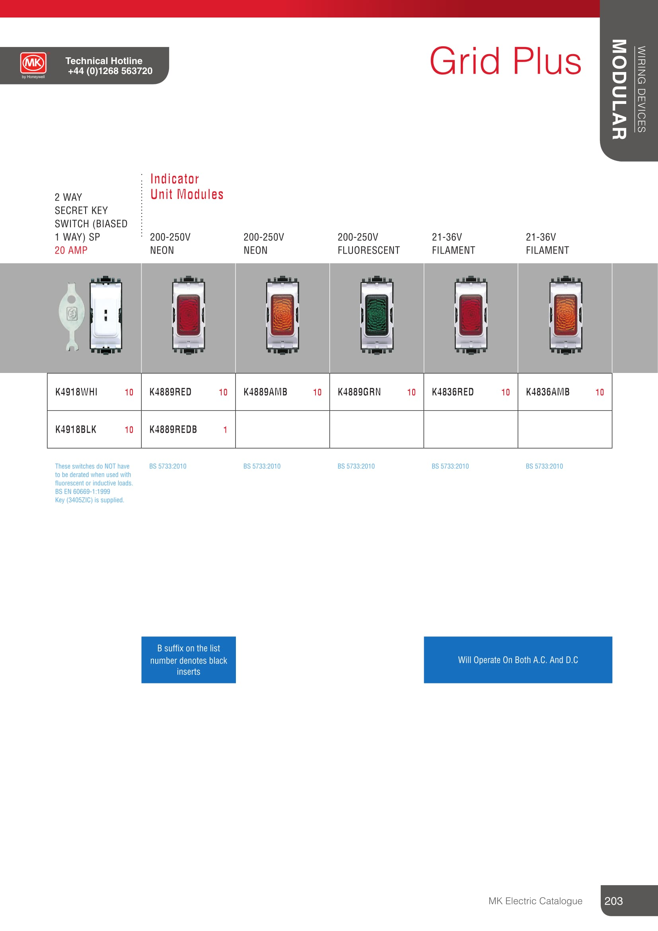

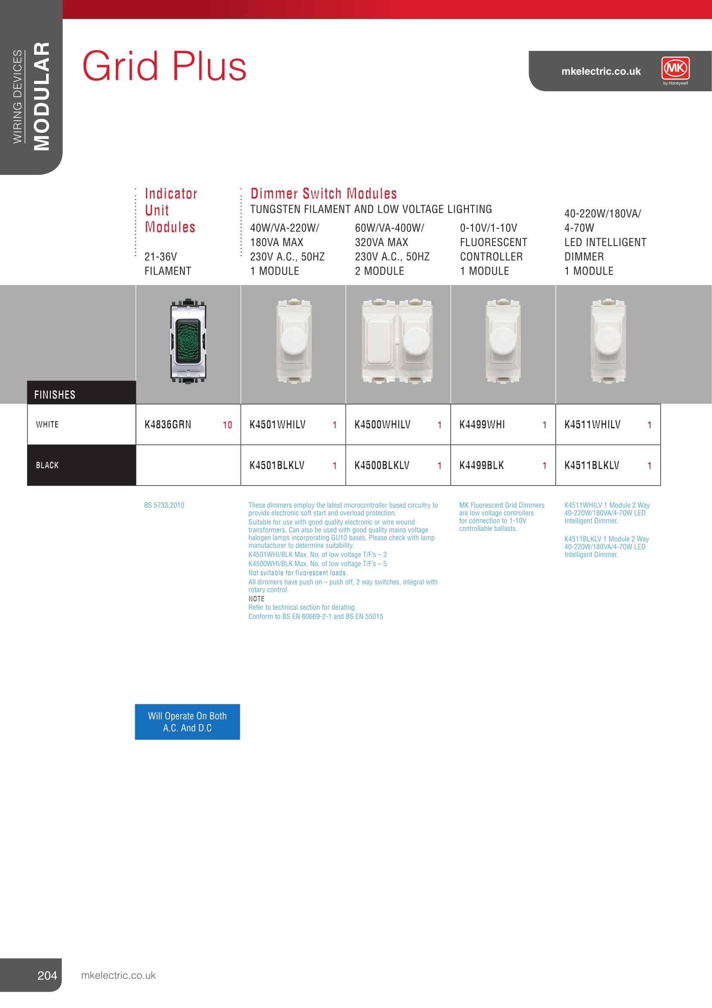
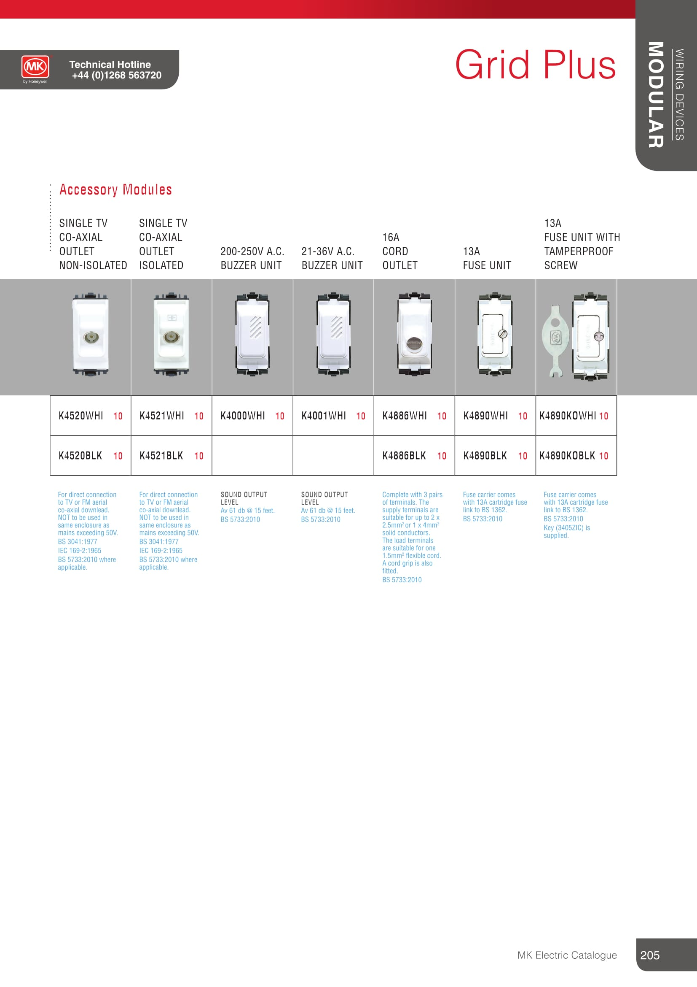

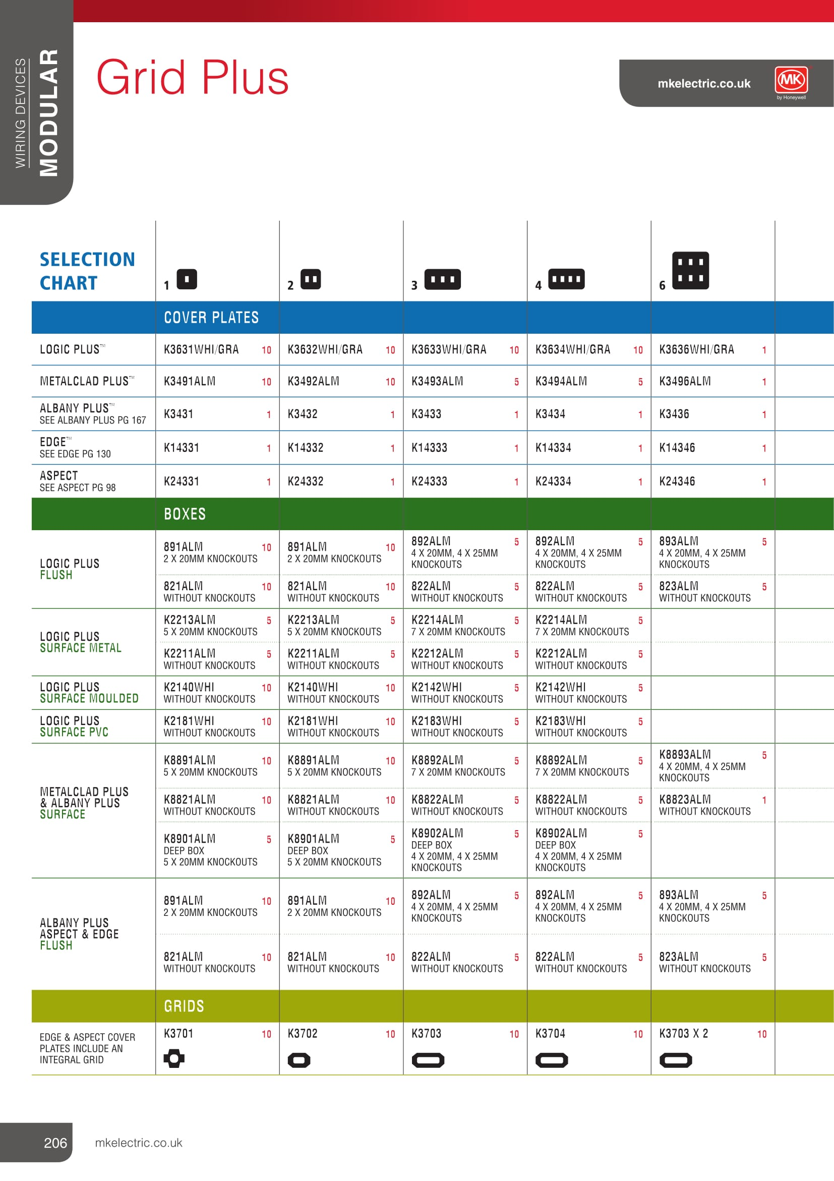
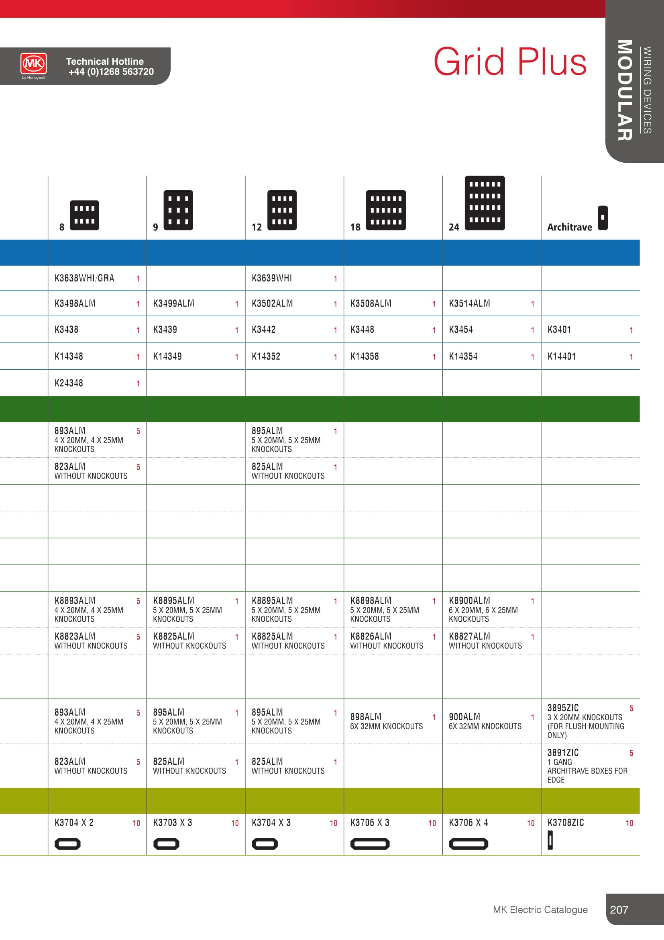
SUPPLIER HOLLAND HOUSE PH 01475 784431

ACEL BATTEN SINGLE SS 58W WHI REF: AC4004

SUPPLIER ELECTRIC CENTRE PH 01475 552500

KLIK CEILING ROSE 3 PIN REF: PCR2000

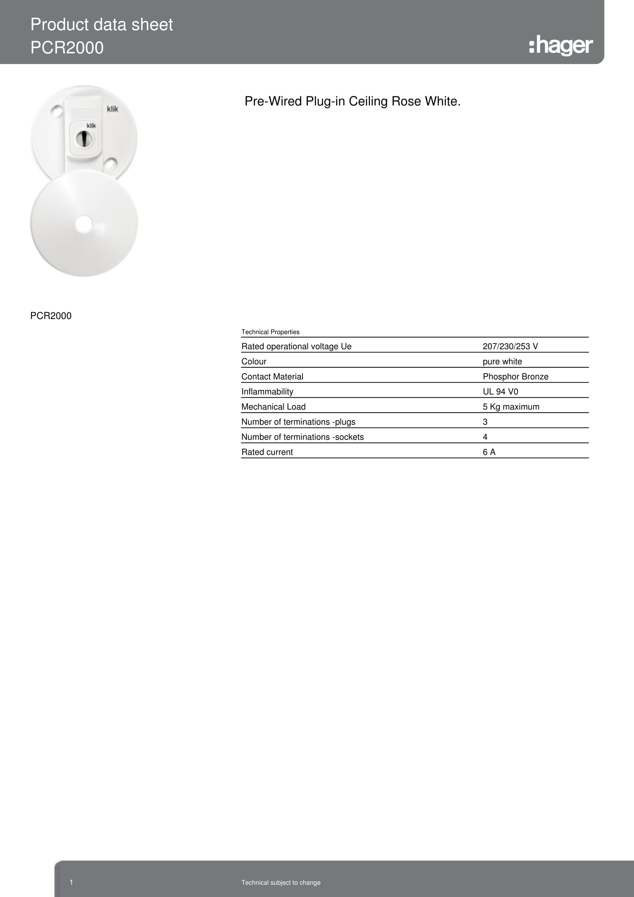

KLIK CEILIG ROSE 4 PIN REFl CR64AX

SUPPLIER AIB GLASGOW PH 0141 445 6633

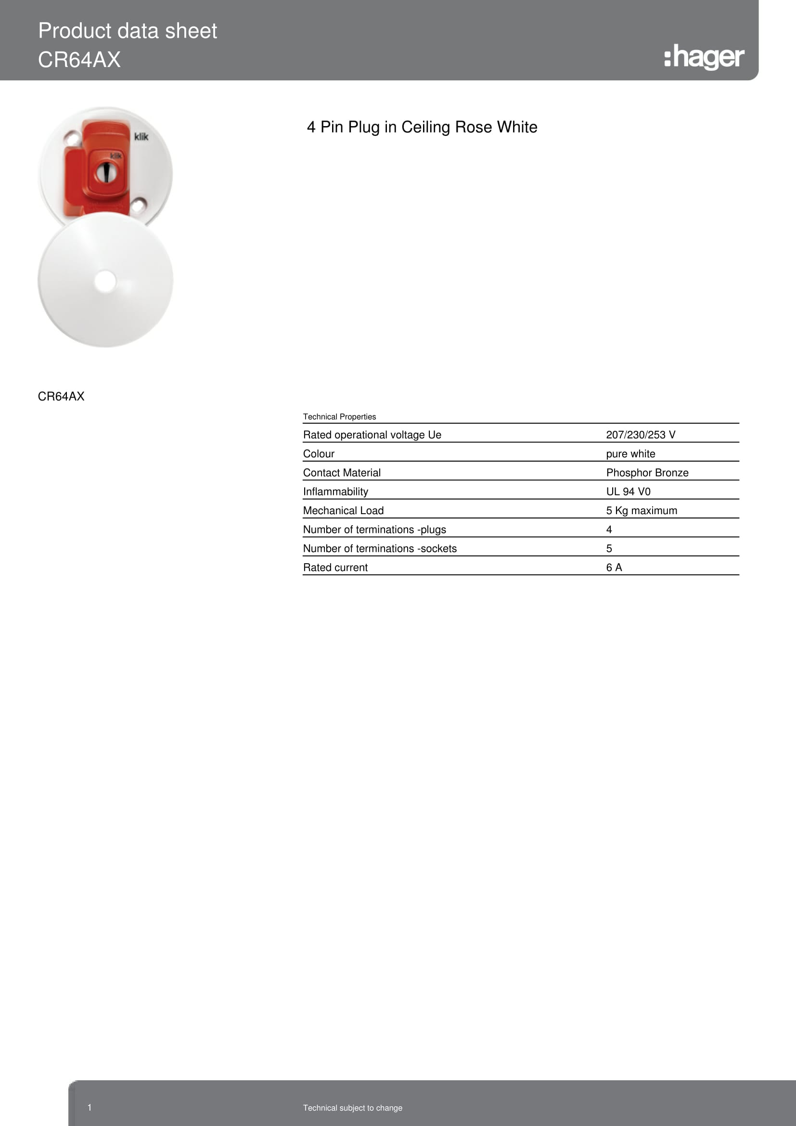

S E C T I O N E I G H T.

Inspection & Test Certificates
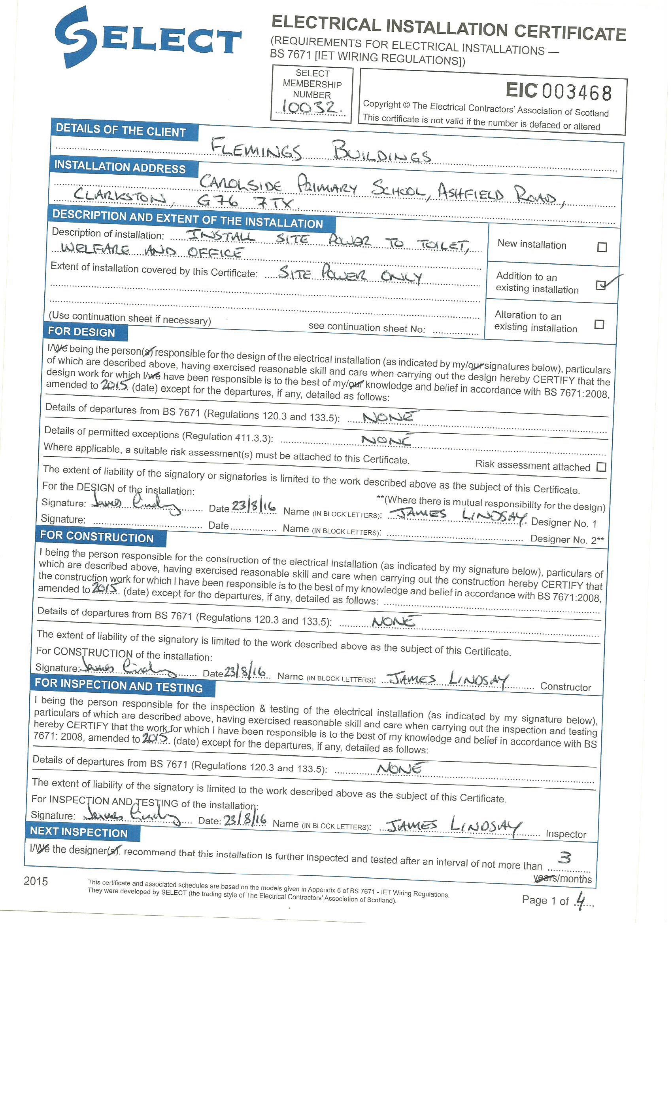
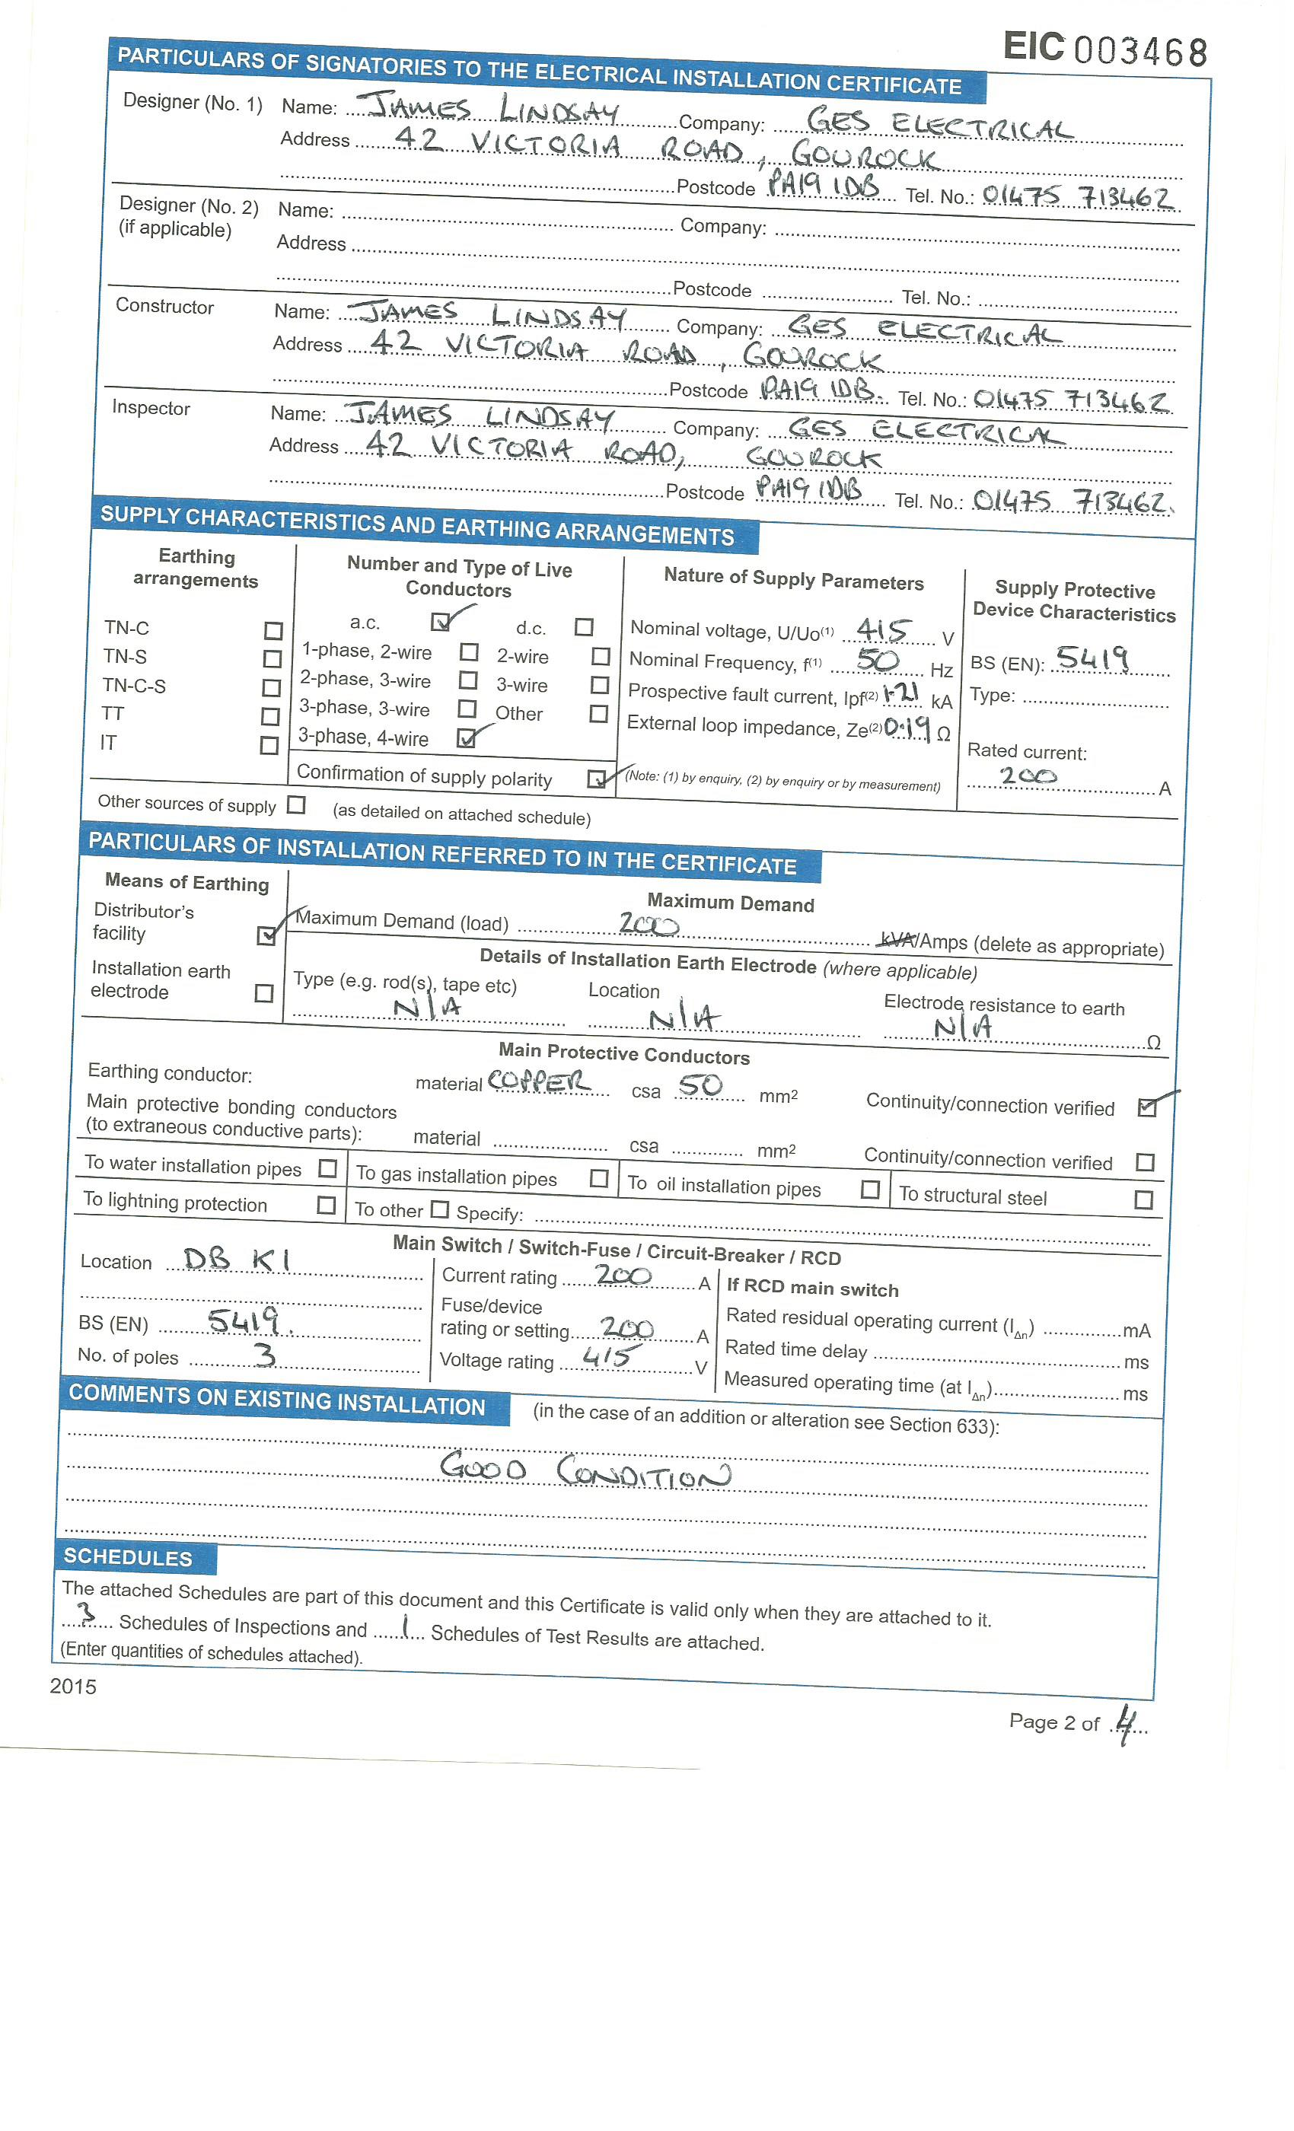
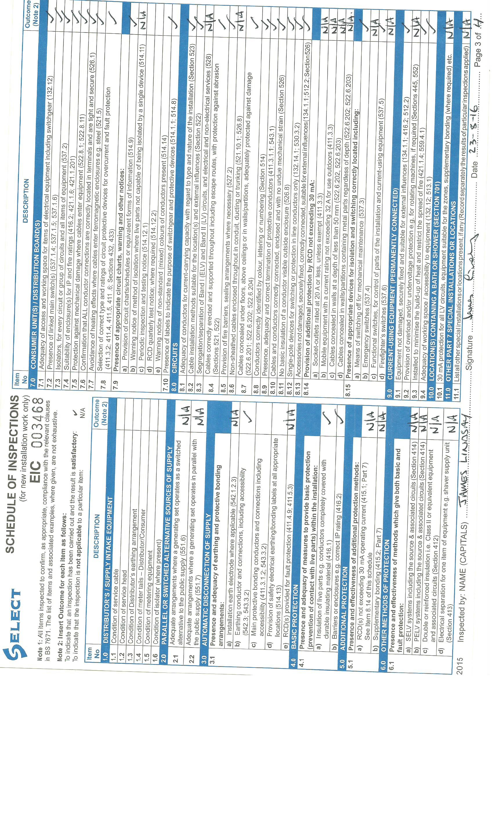
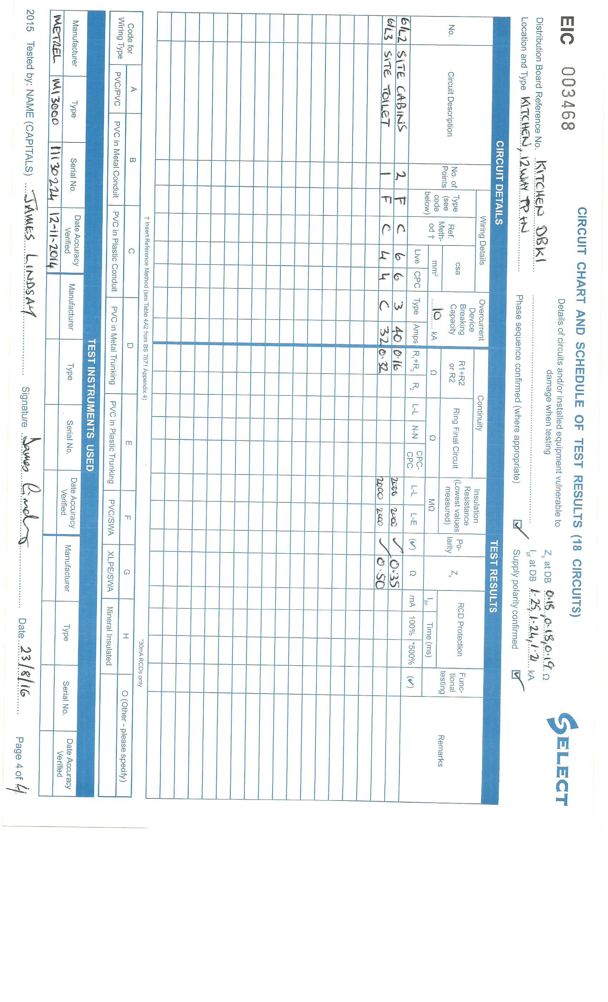
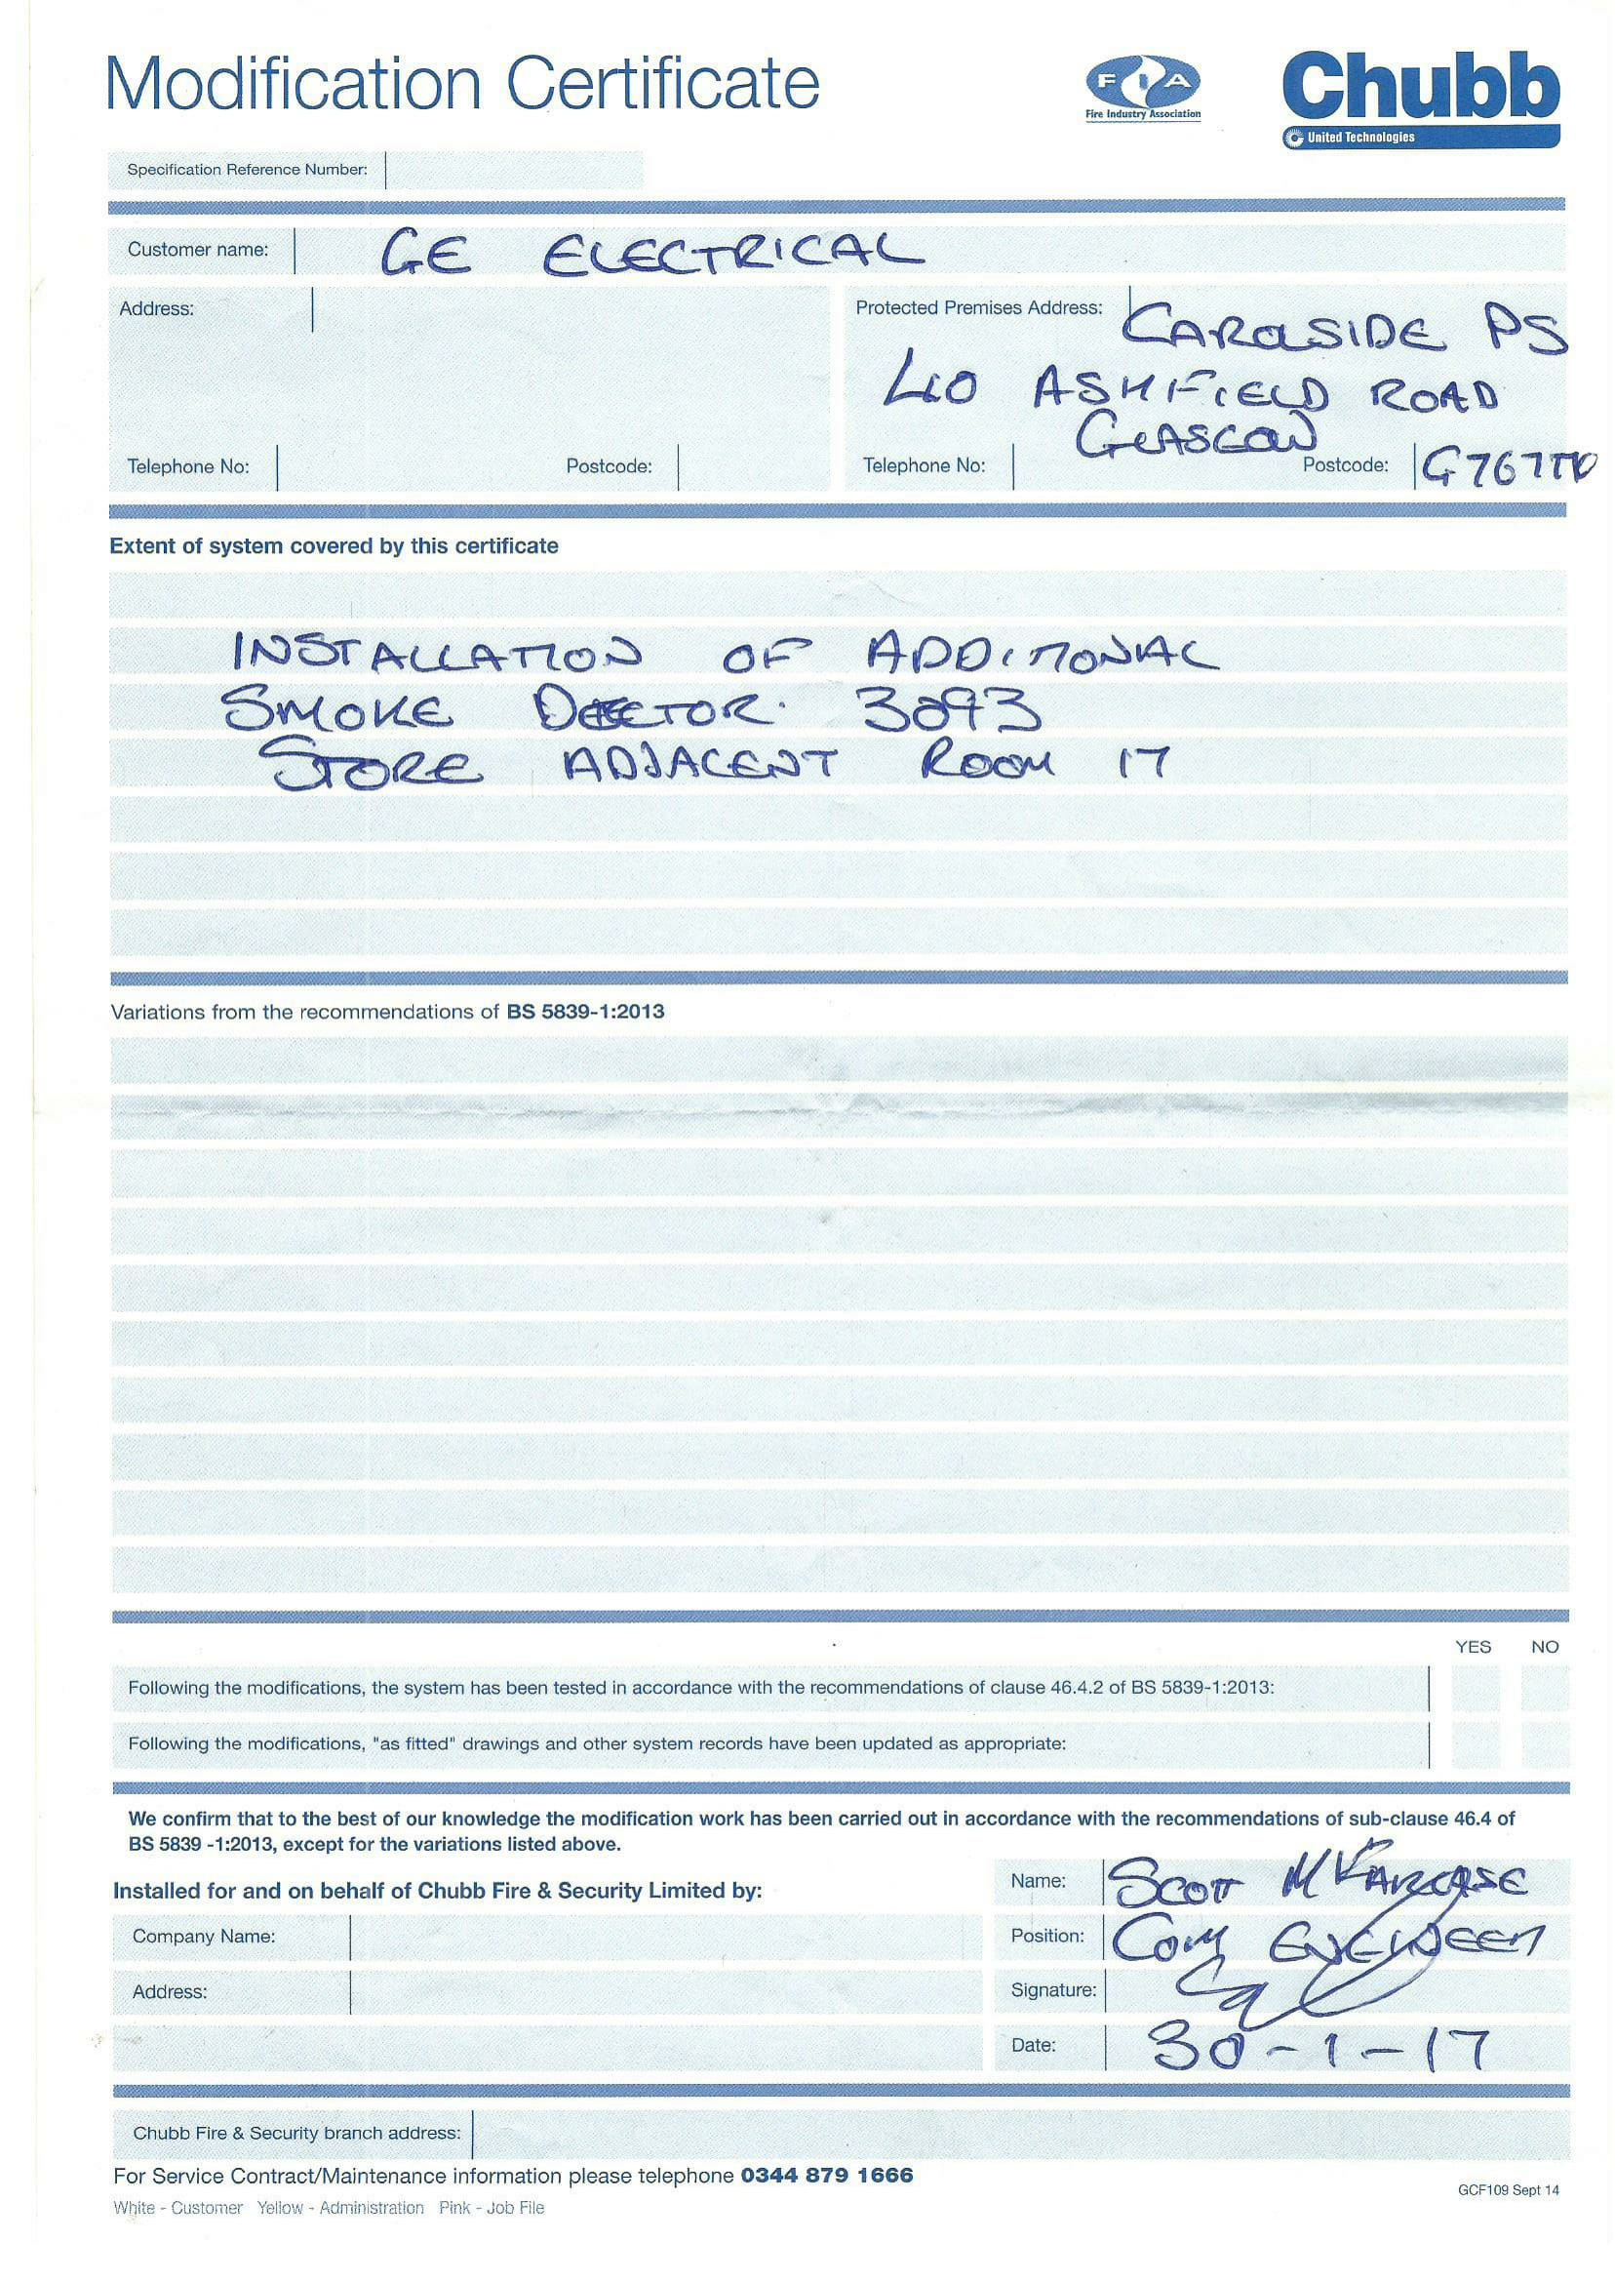
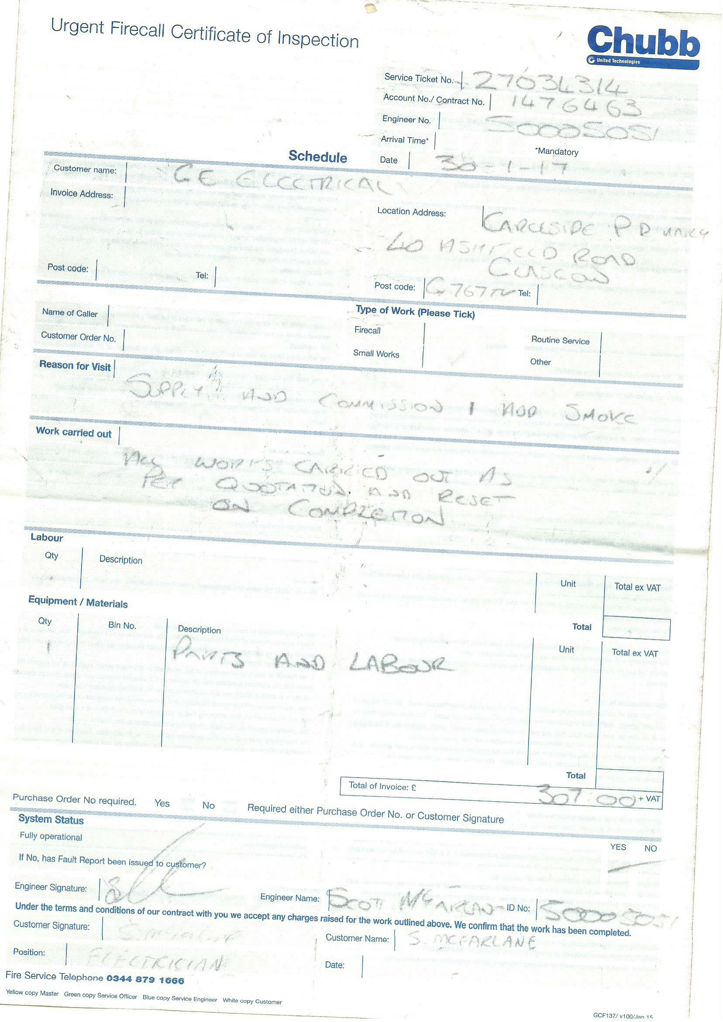
S E C T I O N N I N E.

Contract Drawings

